**Maryborough Central**

**2024**

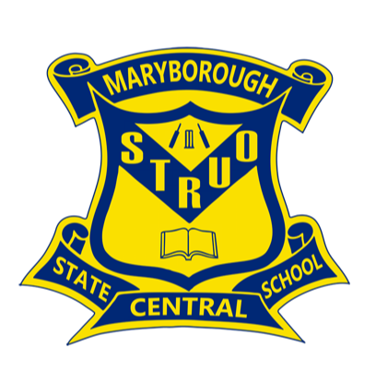

**Parent/ Student**

**Handbook**

NA02125_NA02125_NA02125_NA02125_NA02125_NA02125_**Welcome to Maryborough Central State School**

Dear Parents and Caregivers

On behalf of students, parents and staff I welcome you and your family to the Maryborough Central State School community. Maryborough Central State School has been a facility for education since 1862. Students attending the school come from families whose children have attended the school for several generations as well as families that are new to Maryborough and Central.

We aim to provide a safe, supportive and stimulating school environment for children, staff and parents. Through our Student Code of Conduct we value: **safety, effort, respect and self responsibility**.

Central cares about each child’s learning and each child’s well-being. Our committed staff provides quality learning opportunities for children to meet their educational needs. Teachers plan collaboratively in year levels to ensure consistency in curriculum delivery.

We have a strong music program at Central. Students can learn to play an orchestral instrument in our Instrumental Music program. Our students perform in the community, and at several Music Showcase Evenings during the year. Gala sports day, visiting sports’ development officers and swimming lessons are valuable components of our PE program.

Year 6 students play a key leadership role in the school as School Captains, Vice Captains, Student Council members and Sports House Captains. Other students are actively involved in the Central Production Crew, operating the audio-visual equipment for events in the Hall. Lunchtime activities, often devised by and lead by students, are a great diversion for students of all ages.

I believe that it is important for parents and caregivers to play an active role in their child’s education. Therefore, I strongly encourage you to make contact with your child’s teacher so that you can become familiar with your child’s learning program. Many parents and teachers keep in contact via email. Appointments can be made for before or after school with class teachers or through the school office.

Our fortnightly newsletter; school website and Facebook page are valuable sources of up to

date information for families and the community. Our ladies in the office are among the

friendliest, most helpful and most efficient in the State!

We invite you to become involved in school activities. During the course of a school year we have many events in which you can be actively involved. Parent volunteers help in the tuckshop, in classrooms, in the Library, with our Home Reading Scheme, with Book Fairs and at other special events. We also have a very active P & C Association that you may wish to join. Parents who become involved enhance the life of the school and help build strong home /school /community partnerships.

I look forward to working with you to ensure that your child develops high standards of knowledge, skills, understanding and attitudes in all aspects of their education at Maryborough Central State School.

If you would like to enrol your child/ren at our school I invite you make a time for an enrolment interview. The interview will give us a chance to speak about your child/ren and the opportunity to express any information or ask questions about the school. I see working together with parents and caregivers as one of the most important roles.

**Mrs Rebecca Dickens**

**Principal**

**A Message from the Parents & Citizens Association President**

I would like to take this opportunity to welcome all parents and students to our school and especially those new to the school.

Here at Central, we welcome parent and caregiver involvement in many areas of the school. Any help that you can offer is always appreciated, whether it is in the tuckshop or in the classroom. The school environment is enriched by the valuable work of parent volunteers.

I invite you to attend our P & C Association meetings. The P & C meetings are a really effective way to express your views and become an active member of the school community.

One of the main functions of the P & C Association is to fund raise to support the educational resource needs of our children at school. Central’s P & C does a fantastic job each year in supporting the school and there are many opportunities for parents and caregivers to help raise money throughout the year. If you are interested in helping please contact me or come along to our next meeting. Any ideas or help is always warmly appreciated.

The P & C manages the operations of the school Tuckshop. This is another area where we are always seeking support. There is always a need for Tuckshop helpers. Helping for as little as one day a month is useful so if you can help please contact the President.

**Maryborough Central State School**

471 Kent Street

MARYBOROUGH QLD 4650

[principal@maryboroughcentralss.eq.edu.au](mailto:principal@maryboroughcentralss.eq.edu.au)

[www.maryboroughcentralss.eq.edu.au](http://www.maryboroughcentralss.eq.edu.au)

[www.facebook.com/maryboroughcentralss](http://www.facebook.com/maryboroughcentralss)

|  |  |  |  |
| --- | --- | --- | --- |
| **Campus** | **Contact** | **Phone No.** | **Fax No.** |
| Primary | Mrs Rebecca Dickens Principal  Mrs Leah Ashford HOD-SS | 07 4121 8777 |  |
| Primary | Student absence SMS line | 0460 020 959 |  |
| School Dental Clinic | (Open Mon – Fro) | 07 4122 8861 |  |



**VALUES AND BELIEFS**

*The following statements were formulated within the school community by consensus and reflect the values and beliefs that underpin all operations at Maryborough Central State School:*

* The focus of our school is student learning.
* We value safety, respect, effort and self-responsibility.
* We believe that all students can learn and that achievements should be celebrated.
* We believe that curriculum and pedagogy should cater for individual needs and learning

styles in order to promote optimal social-emotional, academic and physical development.

* We believe that students should participate in a range of experiences that foster life-long

learning, and develop the skills and attitudes to be responsible, active members of society.

* We believe that students learn best in an environment that is friendly, stable, clean, safe,

healthy and stimulating.

* We believe that all students should have access to physical and human resources and

services that foster individual growth and development.

* We believe that genuine two-way partnerships, characterised by honesty and trust,

between students, staff and members of the school and wider community, are essential.

* We believe that staff should continually update and enhance their professional expertise.

**GENERAL INFORMATION (in alphabetical order)**

**ABSENCES**

When children are absent from school, parents are required to either contact the school by telephone, by SMS to 0460 020 959 or send a note, signed and dated with the reason for absence. After roll marking each morning parents of children with unexplained absences will be sent a text message from the school requesting an explanation.

After 3 consecutive days absence without an explanation the school will contact parents by telephone asking them to explain their child's absence. After such an absence, a student is expected to give a note of explanation to their teacher (that includes a date) which clearly explains the reason for the absence.

**ADMISSION TO SCHOOL**

Prep is for students who turn five (5) years by the last day of July of the year they are enrolled. Proof of age is required. Prep is compulsory schooling and students enrolled in Prep are expected to attend 5 days a week unless they have an explained absence.

Regulations provide that a Year One child must attain the age of five (5) years on or before the last day in December in the year prior to enrolment. Year One children may be enrolled at the commencement of the school year, but it is recommended that enrolment be completed in November of the preceding year.

Enrolments are accepted for all year levels throughout the year. Parents and carers should contact the Office to arrange an enrolment interview.

**BELL TIMES**



First Bell 8:50am

School starts 9:00am

Fruit & Veg Break 9:45am

First Break 11:00am – 11:45am

Second break 1:45pm – 2:15pm

School finishes 3:00pm

**BICYCLES & SCOOTERS**

Bike racks are provided inside the grounds. Children are to place bikes in the racks. Cyclists are not permitted to ride bikes within the school perimeter fence.

The racks are out of bounds to all children unless depositing or withdrawing bikes/scooters.

Parents are urged to consider -

(a) Helmets are compulsory by the Traffic Act. Fines apply.

(b) The dangers of allowing small children to ride bikes to school.

(c) The purchase of a lock and chain to secure your child’s bike at school.

(d) A safe route using Bike Ways, Traffic Lights and Crossing Supervisors to make turns

and to cross roads.

**BOOKLISTS**

A booklist for each class is issued annually. It is sent home in the last week of school and is available on our school website. Whilst the list is kept to a minimum, it is expected that each child will obtain items on the list. Pads, pencils etc should be renewed when necessary.

**BOOK FAIR**

Families have the opportunity to purchase books suitable for the wide range of student readers at our annual Book Fair.

**BOOK CLUB**

There are 8 issues of Book Club per year. Commission from sales is paid to Central in credits, which are used to buy resources for our students. If you wish to order any of the books on offer just fill out the Order Form on the back of the booklet, making sure your child’s name and class information are completed. Enclose the order form with the correct money in an envelope and return to the school office by the due date; pay by EFTPOS in the Office; or log on to [www.scholastic.com.au/LOOP](http://www.scholastic.com.au/LOOP) and complete your order.

**CAMPS AND EXCURSIONS**

Educational excursions are undertaken from Prep to Year 6 and relate directly to current curriculum. Year 6 students participate in a leadership camp.



**CHANGES TO FAMILY INFORMATION**

Our Enrolment Form records each child's:

1. Date of birth

2. Religious denomination

3. Names of parents or carers

4. Address and telephone number of parents and adults sanctioned by parents to sign

child out in emergency

5. Particulars on health and doctor's name

6. Family circumstances

Parents are strongly advised to notify the school of any changes to this information, particularly addresses and telephone numbers, so that accurate details are available for use during emergencies. The school needs to be able to contact you during the day.

**COLLECTION OF MONIES**

The correct money forwarded to school should be enclosed in a sealed envelope, showing child's name, class and purpose; eg John Brown, Year 2A, Excursion Money, and placed in the slots situated in the office. Collection of money has a deadline. This is published in the newsletter and individual letters home about events / activities.

**COMPULSORY ATTENDANCE**

The Education Act requires children to attend school on each school day. Exceptions to this rule include - illness, unavoidable causes, other reasons acceptable to the Minister. Students are expected to be punctual. All students should be at school by 8:45am, and preferably not before 8.15am.

**DENTAL CLINIC**

A Dental Clinic exists in the school grounds. The clinic is not permanently manned and the school is not directly involved in the running of the Dental Clinic. Dental concerns and appointments can be dealt with by phoning the clinic on 4122 8861.

**DEPARTURE FROM SCHOOL**

At the end of the school day all children should have left the school grounds by 3.15 pm unless

- they are waiting for transportation

- they have out-of-school activities to attend

- they have school permission to remain.

Children waiting for transport or for the arrival of their parents must wait inside the perimeter fence. Children waiting to catch buses must wait inside the school grounds in the designated area. For their safety, children still at school after 3:15pm must wait at the office.

**LEAVING GROUNDS PRIOR TO THE COMMENCEMENT OF SCHOOL**

Once a student arrives at school, they are not to leave the grounds. Students must be signed out by an authorised adult at the office if they need to leave during school hours.

**LEAVING GROUNDS FOR EXCEPTIONAL CIRCUMSTANCES**

The principal may allow a student to leave the grounds, in exceptional circumstances. Students must seek permission from the Principal if they need to leave the school grounds.

**EARLY ENTRY TO SCHOOL GROUNDS**

All students should be at school by 8:45am, and not before 8.15am. If students arrive before 8.30am, they must be seated in the undercover area until they are given permission to leave. Parents are reminded that limited supervision is provided from 8.30 am until the 8.50 am bell.

**EVACUATION AND TAKE COVER**

Regular practices are undertaken each term to keep the whole school community aware of safe practices in case of emergencies. In case of fire, all staff and students assemble on the school oval adjacent to Sussex Street.

A *Take Cover Plan* is used in response to those situations where it is potentially dangerous to be in an exposed area eg cyclone, hail, severe storm or hostage/siege situations. During Take Cover all staff and students stay indoors, with doors locked, taking cover. Visitors to the school, including parents, are expected to follow school policy on Evacuation and Take Cover.

**FAMILY LAW COURT ORDERS**

Some families are bound by Family Law Court Orders. Documentary evidence of these must be provided to the school, if they exist. Clear legal guidelines are required in these documents.

**HEAD LICE**

Parents will be advised by letter if head lice are an issue in their child’s class. Parents are encouraged to inspect their child’s hair regularly and to commence treatment when necessary. If head lice are seen, parents will be contacted to collect the child. Once treated, the child may return to school.

**HOMEWORK**

Please refer to Appendix 3 for school policy.

**H2O FRUIT AND VEGETABLE PROGRAM**

Students are encouraged to bring a piece of fruit or vegetable to school daily to eat, as managed by the class teacher, during the 1st session of the school day. Drinking water and eating fresh fruit and vegetables promote well-being and readiness to learn.

**INJURIES AND ILLNESSES AT SCHOOL**

The school maintains a first aid kit, and treats minor bruising, scratches etc. When doubt exists concerning injuries, parents are contacted and an ambulance may be called.

When children report themselves ill and are unable to remain in the classroom, parents will be contacted to take them home.

**MEDICATION AT SCHOOL**

**Note: This notice refers to medication prescribed by a qualified medical practitioner.** The School does not hold stocks of patent medicines such as paracetamol, aspirin etc and staff is not permitted to administer this type of medication to children.

The parents of a child who is prescribed medication to take at school must complete a form giving full details. All medication is administered at the office and must be in a packet or container with a prescription label for each child as prescribed by the doctor and administered by the pharmacist. A register of each medication administered is kept at the office.

**INFECTIOUS DISEASES TABLE**

|  |  |  |
| --- | --- | --- |
| **Disease** | **Incubation Period** | **Isolation** |
| CHICKEN POX | For at least 5 days | From school and from non-immune friends until crusts separate |
| COMMON COLD | 1-2 days | In bed for 2 days |
| CONJUNCTIVITIS |  | Until discharge ceases |
| DIARRHOEA (including Giardia) |  | Exclude until diarrhoea has ceased |
| DIPTHERIA | Usually 2-5 days | 16 days after onset, or until 2 negative cultures |
| GERMAN MEASLES | 2-3 Weeks | From school and non-immune friends until rash fades (6-14 days) |
| IMPETIGO (School Sores) |  | Until sores have been treated. Must be covered |
| INFLUENZA | 1-3 days | During acute stage |
| MEASLES | Exclude for at least 4 days from the first appearance of rash | 5 days after appearance of rash |
| MENINGITIS | Usually a week | Two weeks after onset |
| MUMPS | Usually 18 days | Until glands recede |
| RINGWORM, SCABIES, HEADLICE, TRACHOMA |  | Re-admit after being treated |
| WHOOPING COUGH | Exclude for 5 days after starting antibiotic treatment | For 3 weeks after spasmodic cough |

**LATE ARRIVAL AT SCHOOL**

Children are expected to be in the school grounds by 8.45am so that learning can commence by 9.00am. For this reason, a bell is rung at 8.50 am to summon children to prepare for lessons. Late arrivals should report to the office to obtain a late slip before going to class.

**LIBRARY**

AN00790_

Borrowing: Children may borrow books for personal loans.

Years Prep,1 and 2 1 book.

Years 3, 4 and 5 2 books (1 fiction, 1 non-fiction).

Years 6 3 books (maximum of 2 fiction).

Return: The period of the loan is 1 week.

Care: Parents are asked to ensure that books are cared for at home and returned by the

due date. Parents are asked to provide a Library Bag to protect books while they

are out of the library.

Losses: Losses are not normally expected; however, if a book is lost by a child, it should

be either replaced or paid for by the parent.

**MOBILE PHONES, PAGERS, PORTABLE CDs AND MP3 PLAYERS**

The use of mobile phones, pagers, portable CD and MP3 players, personal digital assistants and similar electronic devices in class is disruptive to the learning environment of all students and is strongly discouraged.

Students wishing to use these devices in special circumstances need to negotiate through the Principal.

All phones and players need to be signed in at the office before school starts and collected after 3pm. Refer to Appendix 4

**NEWSLETTERS**

Newsletters are issued fortnightly on Friday to the youngest in all families. The newsletter is also emailed to parents who request it. On occasions, special newsletters are issued. Parents are asked to enjoy the newsletter with their child each fortnight.

**PARADE**

Whole school parades are held every Tuesday morning at 9am in the Hall. Parade is organised and conducted by the school leaders in conjunction with the Principal. Students are acknowledged for positive learning, appropriate social behaviours and good attendance that occur throughout the week. They are rewarded with certificates of achievement. Families are encouraged to attend.

**PARENT / TEACHER PARTNERSHIPS**

Strong parent / teacher partnerships are an essential part of each child’s education.

Parents are encouraged to:

* meet regularly with their child’s class teacher to discuss their child’s progress and curriculum;
* attend regular meetings of the P & C Association at which school policy is discussed and reports on school activities are given;
* attend school functions such as Sports Days, Central Fair, Socials, Discos;
* attend special information meetings arranged for parents by teachers; and
* participate in school committees set up for specific purposes such as Reviews / Strategic Planning and Environmental Scans

**PARENT VISITS TO CLASSROOM**

Parents are most welcome to make appointments with class teachers at mutually convenient times. We encourage appointment times to be outside lesson time so that the teaching / learning process receives maximum available time.

If you would like to come in and volunteer in your child/s class then please see the class teacher. You will need to sign in and out at the office on the days that you are present.

BD07206_

**REPORTING TO PARENTS**

Reports are sent to parents twice per year – at the end of first semester in June / July and at the end of second semester in early December. Parent / Teacher interviews are conducted in the Hall towards the end of terms 1 and 3.

Parents of students are invited and strongly encouraged to visit the school regularly to discuss their child’s progress with the class teachers and / or the Principal.

**SAFETY**

To ensure all children are safe at school the following guidelines are provided:

* Students are not allowed in classrooms unsupervised.
* Students are not released from class before the official school bell.
* During sport or physical education, a teacher is on duty to see that children participate safely.
* Students are not allowed to use electrical equipment without supervision.
* Equipment and resources must be returned to safe storage areas after use.

**SAFE, SUPPORTIVE, DISCIPLINED SCHOOL ENVIRONMENT**

The school’s Student Code of Behaviour is available on request. An abridged version is located at the back of this handbook - please see Appendix 1. In particular, all staff members have a strong commitment to dealing with bullying proactively and reactively in an effective and timely way.

**SCHOOL CROSSING SUPERVISORS and PEDESTRIAN CROSSINGS**

School Crossing Supervisors are assigned to Sussex Street, Kent Street and John Street crossings. Children and parents should use this service at all times.

Parents driving to and from the school are asked to respect the road laws with regard to pedestrian crossings and parking / loading zones.

Parents are requested not to summon children across roads at places other than the three designated pedestrian crossings above. If possible, please use Sussex Street, as there is less traffic, more parking space, and children do not have to cross a road.

**SCHOOL PARKING**

Parents are **not authorised** to use the Maryborough Education HUB staff car park. It is out of bounds to children for safety reasons. Parking is available to parents in the streets around the school.

**SAFETY BOUNDARY**

As you are all aware our safety boundary fence has been completed with lockable gates at all school entrances apart from Kent Street. All gates to the school are locked from 9:15am – 2:45pm, for the safety of our students and school community. Our Kent Street entrance will remain open at all times for access throughout the school day. All visitors to our school are to report to the office upon entering the school grounds.

**SPORTS AND ACTIVITIES**

Gala Sports Day is arranged in the Maryborough District during Term 1 and Term 3 of the school year. Sports on offer include:



Soccer, Rugby League, Hockey, Tennis

Touch Football, Netball, Basketball and AFL.

### SPORT HOUSES

***House name Colour***

***COOK*** *(Named after Captain James Cook who charted Australia’s east coast)* Green

***FLINDERS*** *(Named after Matthew Flinders who circumnavigated Australia)* Blue

***PETRIE*** *(Named after Edward Petrie, a Queensland pioneer)* Purple

### STUDENT DRESS CODE

Please see Appendix 2

**STUDENT PROTECTION POLICY**

The Student Protection Policy is designed to protect students and to ensure that schools are safe and supportive learning environments. Students are expected to contact their class teacher or Principal about concerns they have. Parents are also strongly encouraged to bring concerns to the attention of school staff. Central actively responds to concerns raised about student safety by following departmental procedures.

**SUPPORT SERVICES**

Children with diverse needs such as gifted and talented, learning difficulties, hearing impairment have their educational needs met through Learning Support Plans.

Parents with concerns should approach the class teacher to arrange a referral to support staff. Parents are expected to attend meetings with support personnel.

**VEHICLES IN SCHOOL GROUNDS**

It is potentially dangerous to drive vehicles in the school grounds. No vehicles are permitted in the grounds without prior approval of the Principal.

**VOLUNTARY PARENT WORKERS**

Individual teachers utilise the assistance of voluntary parents in a variety of ways - reading, cooking, computers etc. If you are able to assist please negotiate mutually acceptable times with class teachers.

**CURRICULUM**

**PREPARATORY YEAR**

Prep is a compulsory, full-time preparatory year. Central is committed to a preparatory program that has an academic focus, and is child-centred and activity-based. We challenge children, giving them every opportunity to develop and grow to their full potential. In Prep (and the Early Years), there are five contexts for learning: Play, Real-life situations, Investigations, Routines and transitions, and Focused learning and teaching.

Central aims to develop in students:

* Social and emotional competence (independence, taking risks, asking for help)
* Health and physical well-being
* Early literacy and numeracy skills
* Active learning processes (thinking and solving problems).
* Foundations for successful learning.

We integrate both child-initiated and teacher-initiated experiences in the program. We plan a flexible program allowing teachers to respond to the spontaneous learning situations that occur during the course of a school day.

**YEARS 1-6 KEY LEARNING AREAS**

Our curriculum is organised around the Australian Curriculum (AC) and the eight Key Learning Areas. Key Learning Areas include English, Mathematics, Science, Humanities and Social Sciences (HASS), The Arts (including Music), LOTE, Technology and Health and Physical Education.

The planning of class units considers contexts which are based on real world issues / situations (eg family, home, community, global), assessment data, student needs, interests and backgrounds. Each unit includes orientation, enhancement and synthesising phases including a ‘Learning Celebration’ to share students’ new learnings with others. Units incorporate learning experiences that promote recognition of difference, intellectual quality, connectedness and supportive classroom environments.

**ENGLISH**

The development of Literacy skills from Prep to Year Six will remain a major focus at Central. Since 2012, Central has implemented KLAs using resources from the Australian Curriculum. This framework contains very detailed content, strategies and assessment processes.

The development of skills in oral language, reading comprehension and writing continues to receive strong emphasis across all primary years. Students at Central will study English for a minimum of 10 hours per week.

The development of reading and writing receive important emphasis. Strategies include:

* explicit teaching of reading and writing in all year levels, supported by Teacher Aides each day in each class
* the Home Reading Program focuses on the development of positive habits through daily reading from the earliest possible opportunity
* ensuring a range of stimulating school and library reading resources
* targeted intervention and extension programs where needed
* implementation of the School Assessment Overview

The *School Assessment Overview* is used to record student progress in the areas of phonics (Get Reading Right), camera words, spelling, reading and comprehension. Student results are regularly monitored and analysed to form the basis for differentiated programs to enhance individual student learning.

**MATHEMATICS**

Like Literacy, the development of Numeracy skills from Prep to Year Six will also remain a major focus at Central. Since 2012, Central has implemented Maths programs from the Australian Curriculum.

Competence in computational skills and the application of concepts in number and algebra, measurement and geometry, and statistics and probability will be developed.

Learning activities provide purposeful real life and life-like activities building on previous experiences. Students will be actively involved in discovery learning situations using concrete manipulative materials, computers and calculators. They will be encouraged to reflect on their learning and to discuss their discoveries and outcomes.

The *School Assessment Overview* is used to record student progress. Data gathered informs specific programs to be developed for students who are excelling or experiencing difficulties in these areas. Students will study Maths for a minimum of 5 hours per week in years P-3 and 7.5 hours per week in years 4-6.

**SCIENCE**

Central’s Science Program is organised around the Australian Curriculum and the Primary Connections program. Deep knowledge and effective skills in the areas of science inquiry skills, science as a human endeavour and science understanding will be developed. Students will study science for a minimum of 1 hour per week.

The 5 Es inquiry-based teaching and learning model will be used to implement units of work. Students will develop conceptual understanding when they:

* **Engage Explore Explain Elaborate Evaluate**

**HEALTH, HASS, MEDIA, VISUAL ARTS, DANCE AND TECHNOLOGY**

Teachers will embed AC standards to plan meaningful, relevant and challenging learning activities in these areas.

**MUSIC (THE ARTS)**

All students at our school attend the equivalent of at least one 30 minute music lesson once per week where they enjoy singing and rhythm, using a wide variety of instruments, and music making.

Children from years 3 - 6 are invited to join the school choir. The choir performs on assembly, at the Eisteddfod, Choral Fanfare and at community events.

All years 2 and 3 students participate in a violin program (instruments provided), where our Strings teacher leads them through learning to play the violin in two twenty minute sessions per week.

**INSTRUMENTAL MUSIC PROGRAM**

EN00501_

Tuition is given for one lesson per week in orchestral instruments, to those children whose parents have agreed to and paid for their participation in the Instrumental Music Program. Brass, woodwind, percussion and strings are taught. Parents need to provide instruments for all sections except percussion, cello and euphonium. Recruiting takes place in November for Strings in Year 3, and woodwind and brass in Year 4. Parents should contact the school for further particulars.

When children are accomplished enough, it is expected they will play in the school concert band and string orchestra. These groups are committed to public performances throughout the year and members are expected to participate. Several very enjoyable Music Showcase Evenings are also held during the year.

**ICT – INFORMATION & COMMUNICATION TECHNOLOGY**

The use of computers in classrooms is integrated within the 8 Key Learning Areas of the curriculum. All students at Central participate in the Digital Technologies Curriculum. This curriculum focusses on coding, robotics and design technologies. The school maintains a ratio of at least 1 computer to 5 students, with computers located in classrooms and in the Library Computer Lab. Central uses a Managed Operating Environment based on a Windows platform. Software resources include a focus on literacy and numeracy skills. iPads and laptops are also used for focused small group practice of learning skills.

Parents are asked to sign an Internet Agreement form for their child before students access the Internet for studies.

BS01180_

**LOTE (JAPANESE)**

Students in Years 5 and 6 study Japanese for 1 hour per week with a

specialist teacher. Students are exposed to both language and cultural

knowledge in their studies. Consultation with classroom teachers allows

for the integration of Japanese studies in the wider curriculum.

**PHYSICAL EDUCATION**

The school enjoys the services of a Physical Education specialist. Each class has weekly lessons in this subject. Protective footwear and hats must be worn at all times.

* Gala Day sport occurs for years 5 and 6 in Terms 1 and 3
* School Athletics Carnival occurs in Term 2 or 3
* Swimming programs are usually undertaken in Term 1 for years 4 & 5

and Term 4 for years 1, 2, 3 subject to availability of the Council pool

**RELIGIOUS EDUCATION**

Currently Religious Education is not taught in state schools in the Wide Bay area. Parents will be notified if this changes. Parents who do not wish their children to attend will be asked to advise the school in writing.

**ONLINE LEARNING OPPORTUNITIES**

There are a number of opportunities for students who are excelling in their classroom learning to access online learning. These learning usually focus around the STEM subjects of Science, Technology, Engineering and Maths. Students grades and attendance will be considered when allocating them to these programs. If this is an area of strength for your child please make not of this upon enrolment.

**POSITIVE BEHAVIOUR FOR LEARNING (PBL)**

The PBL committee, which includes teachers, aides, admin and a parent, meets fortnightly to analyse and discuss behaviour data with the purpose of identifying issues and developing plans and resources to address them.

**SPECIAL EDUCATION PROGRAM (SEP)** The Special Education Program provides programs and support services for students with disabilities whose educational needs are identified through the EAP (Education Adjustment Profile) process. Our team has access to a range of specialised personnel, to assist with the development, management and monitoring of individual programs.

Support for students with disabilities is provided through an inclusive model. The students are integrated into regular classrooms and supported by inclusion teachers in a variety of ways such as:

* in class assistance
* modification of class programs
* small group work
* individual programs
* real life experiences
* alternative programs

according to Individual Education Program needs.

EAPs (Education Adjustment Profiles) are reviewed and written once a year and take into account factors such as: the nature and extent of disability, needs, interests and abilities of the students. These plans assist teaching staff to provide relevant learning programs for the children to meet their individual needs.

Students who need regular social/emotional support to enable them to access their class activities productively, are engaged with a support teacher aide and/or the chaplain for short sessions during the week. Students also have access to a Guidance Officer and a wellbeing/engagement social worker.

**TAC (TEAM AROUND THE CHILD) COMMITTEE**

The purpose of the TAC Committee is to assist the school to prioritise access to services which will promote personal and academic development of all students. Personnel who may provide intervention for students include: Inclusion teachers (formerly Support Teachers: Literacy and Numeracy), Guidance Officer, Speech Language Pathologist, HOI and Principal.

Our Student Engagement teacher coordinate individual student / small group support in literacy and numeracy through –

* the QuickTest of oral language for all preps and other new students
* individual speech language programs provided by the Speech Language Pathologist
* TAP into Speech and Support-A-Talker programs
* collaboratively planned individualised learning support plans for students
* planned group support e.g. oral language, sensory motor skills, reading strategies, writing strategies, numeracy concept development
* student engagement teacher, teacher aide and parent support to individuals, small groups and classes
* extension groups for students displaying excellence in curriculum areas

Appendix 1

Maryborough Central State School



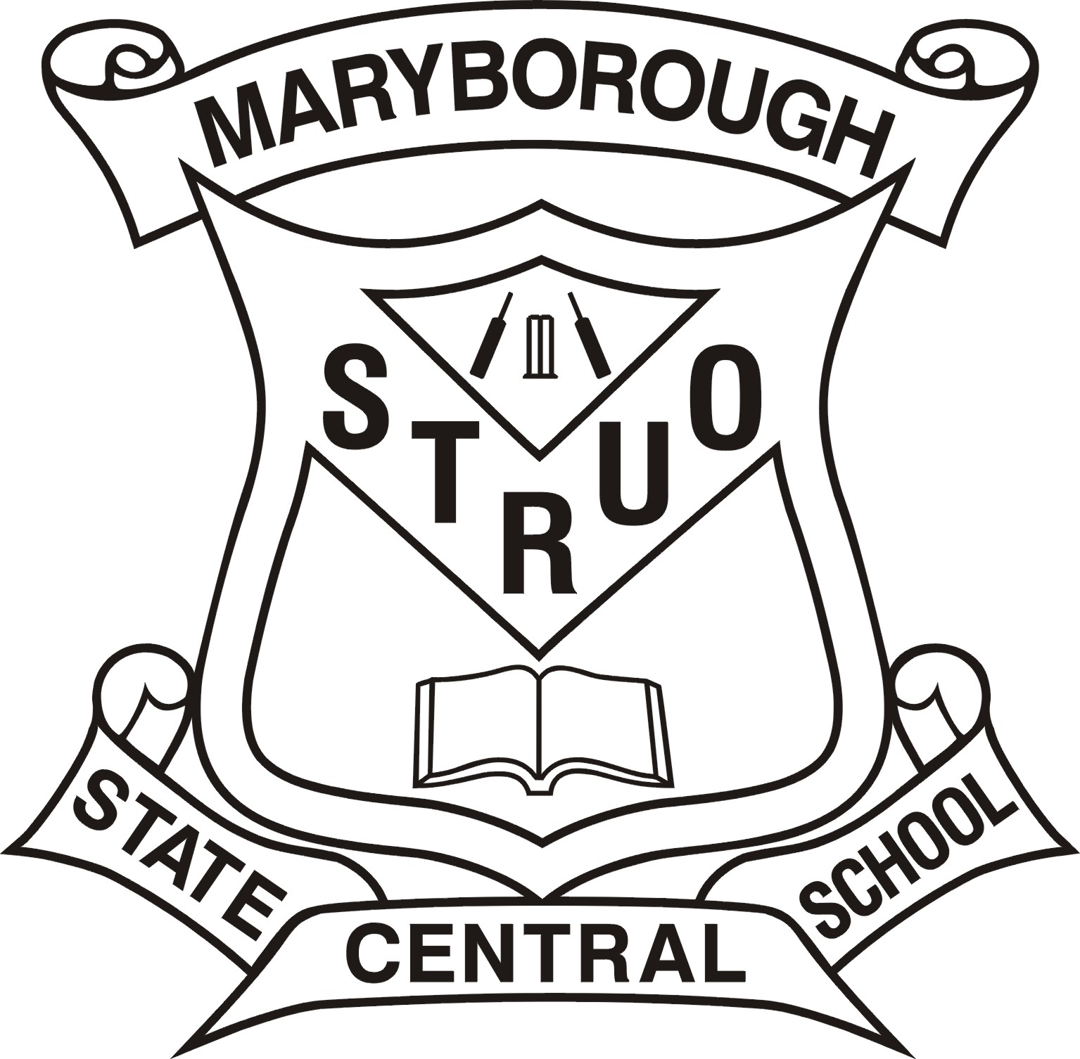

*Student Code of Conduct*

Abridged Version – MCSS Enrolment Package

Full Version available at [www.maryboroughcentralss.eq.edu.au](http://www.maryboroughcentralss.eq.edu.au)

**Rationale**

Education Queensland is committed to provisions that ensure all young Queenslanders have a right to and receive a quality education*.*

Maryborough Central State School upholds this commitment through the promotion and consistent implementation of its Responsible Behaviour Plan for Students. Maryborough Central State School developed this plan in collaboration with our school community – parents, staff and students. Broad consultation was undertaken through meetings held throughout the latter part of 2016. A review of school data sets from 2020 – 2021 relating to attendance, absenteeism, school disciplinary absences and behaviour (both positive and incident records) also informed the development process.

A team of staff and parents leads the development of the *Positive Behaviour for Learning (PBL)* approach in the school. This lead group meets regularly to consult with staff and community. Their collective work drives the review of the school plan and the key strategies that arise from it.

At Maryborough Central State School there is an expectation that students comply to acceptable social standards of behaviour that promote a supportive, well-disciplined and safe learning environment. Of high importance is the development of self-responsibility, personal accountability and the ability to behave in a safe, respectful manner in the school environment and in the wider community.

Socially-responsible and appropriate behaviour is viewed as vital to success in both the workforce and in life. Safety, effort, respect and self-responsibility are promoted through the implementation of the Student Code of Conduct, addressed and developed both discretely (as a stand-alone curriculum topic) and intrinsically (within other curriculum contexts).

**School beliefs about behaviour and learning**

At Maryborough Central, our vision is the promotion and development of a safe and supportive environment in which all people are:

1. Independent Learners
2. Confident and Self-managing
3. Socially Responsible
4. Effective Communicators and
5. Happy and Involved

All areas of Maryborough Central State School are teaching and learning environments. We consider behaviour management to be an opportunity for valuable social learning as well as a means of maximising the success of academic education programs. We are implementing the research validated *Positive Behaviour for Learning* framework to achieve our identified social behaviour and academic outcomes - reflected in the core elements of the school’s learning approach to behaviour:

1. Principal leadership of a team approach to behaviour
2. Parent and Community engagement
3. Data informed decision making
4. Clear consistent expectations for behaviour and
5. Explicit teaching of appropriate behaviour to all students

Our Student Code of Conduct outlines our systems for facilitating positive behaviours, preventing new cases of problem behaviours and responding to unacceptable behaviours. Through our school plan, shared expectations for student behaviour (our ‘Behaviour Curriculum’ in the form of a matrix) are plain to everyone, assisting Maryborough Central State School to create and maintain a positive and productive learning and teaching environment, where ALL school community members have clear and consistent expectations and understandings of their role in the educational process.

Our school community has identified the following three broad school rules / expectations to teach and promote our high standards of responsible behaviour:

* **Self-Responsibility**
* **Safety**
* **Respect**
* **Effort**

Our school rules have been agreed upon and endorsed by all staff and our school P&C. They are aligned with the values, principles and expected standards outlined in Education Queensland’s Code of School Behaviour.

Our School Community Behaviour Code/Rules are as follows:

**A) SAFETY**

School community members will act in a lawful and responsible manner that presents no danger to the physical or emotional security of themselves or others.

Safety is exhibited in such conduct as:

1. Safe use of equipment
2. Acknowledgment and respect of the personal space of self and others
3. Following of school rules, routines and instructions
4. Moving safely through the school environment
5. Resolution of conflict without violence
6. Sun safe practices

**B) EFFORT**

School community members will be mindful of the fact that the primary aim of schooling is student learning. Each member will actively fulfil his / her role in promoting this process to the best of his / her ability.

Effort is exhibited in such conduct as:

1. Attempting and persisting with set work to best of ability
2. Effective management of time
3. Positive contribution to the life and activities of the school
4. Demonstration of an interest in the life of the school
5. Cooperation in support plans (eg. Learning Support, Behaviour Support, EAP)
6. Maximising performance and participation at school
7. Representing the school with good sportsmanship, pride and enthusiasm

**C) RESPECT**

School community members will treat each other with courtesy and consideration at all times, being mindful of the rights and differing responsibilities of each person. Such courtesy will be reflected in both action and communication.

Respect is exhibited in reasonable conduct including:

1. Respecting self
2. Respecting property of self, others and the school environment
3. Respecting and appreciating the rights, dignity and worth of others
4. Attentive listening
5. Appropriate communication
6. Maintaining positive, appropriate and non-discriminatory interactions with people

**D) SELF-RESPONSIBILITY**

School community members will endeavour at all times to make appropriate behaviour choices relative to the social context, and accept accountability for the outcomes of their actions.

Self-Responsibility is exhibited in such conduct as:

1. Following instructions of supervisors
2. Making appropriate choices without supervision
3. Accepting responsibility for own behaviour
4. Having appropriate equipment for tasks
5. Being honest with self and others
6. Solving problems in a peaceful, positive way
7. Actively seeking support and listening to advice

There is recognition in the school community that such behaviour expectations not only have a social context but are skills-based. Behaviour standards have been collaboratively established for students to promote appropriate school behaviour and to assist in the diagnosis and support of student behaviour problems. This behaviour framework is as follows:

|  |  |  |  |  |  |
| --- | --- | --- | --- | --- | --- |
| **Maryborough Central SS** | **Universals** | **Moving** | **Caring** | **Playing** | **Learning** |
| **Safety**  *…that when community members create an emotionally, socially, and physically safe and supportive environment, everyone can do their best.* | * Hands and feet to yourself * Follow adult directions * Stay in appropriate areas * Put rubbish in bins * Use equipment safely * Wear a wide brimmed hat and shoes * Wear a sunsmart swim shirt * Wear sunscreen for outdoor activities | * Walk inside * Walk on concrete * Walk on left of stairs * Line up quietly * Classes walk in 2 lines, quietly * Stay sitting to eat your food * Follow classroom rules * Ask permission to leave learning areas * Move off stairs and stairwells promptly | * Knock and wait before entering rooms * Stay sitting to eat your food * Eat your own food * Wash your hands with soap * No climbing of trees * Do not pick up sticks/stones/seedpods | * Play the game and follow the rules * Be a good sport * Participate in school approved games only * Stop activity on the first bell * No playing in tuckshop area | * Walk inside * Sit on chairs correctly * Follow classroom rules |
| **Effort**  *…that when community members are organised and willing to work persistently, it is more likely that everyone will reach their personal goals*. | * Do your best * Be organised * Be on time * Follow adult directions * Tidy all areas after use * Put rubbish in bins * Positive involvement in school activities | * Be quick to set-up and quick to pack up at play * Ask permission to go to the Office * Classes walk in 2 lines, quietly | * Knock and wait before entering rooms * Listen to others when they are speaking * Remember to use your manners * Ask permission to go to the Office | * Play fair * Be a good sport * Be quick to set-up and quick to pack up | * Attempt all work- have a go * Ask for help * Join in discussions * Keep trying, keep at it * Focus- listen, think, remember * Listen to others when they are speaking |
| **Respect**  *…that when community members value themselves and others, they will develop positive relationships and manage conflicts, proactively working towards repair and harmony.* | * Be honest * Cooperate with, include and encourage others * Work towards a solution * Celebrate success * Follow adult directions * Use good manners * Use friendly voice/words/face/body * Care for own and others’ property * Put rubbish in bins * Tidy areas after use * Use an appropriate voice to match the area/activity | * Classes walk in 2 lines, quietly * Move quietly, with purpose | * Knock and wait before entering rooms * Consider others’ wellbeing * Allow for the privacy of others * Eat only your lunch * Eat food in eating areas only | * Play fair * Be a good sport * Ask for help when needed * Care for the environment | * Play fair * Ask for help when needed * Believe in yourselves – have confidence * Hands up to speak * Consider others * Help your peers to learn |
| **Self** -**Responsibility**  *…that when community members are self-managing, through taking responsibility for relationships, safety, and working hard (safety, effort, respect), the school environment runs well.* | * Do your best * Be prepared and be on time * Cooperate with, include and encourage others * Use good manners * Use friendly voice/words/face/body * Use an appropriate voice to match the area/activity * Follow the classroom rules * Follow adult directions * Stay in appropriate areas * Ask permission to leave learning areas * Stop activity on first bell and be ready at the line by second bell * Work towards a solution * Accept consequences * Wear correct school uniform * Sign in all electronic equipment to Office before school * Leave toys at home * Tidy areas after use * Put rubbish in bins | * Move quietly, with purpose * Students go to tuckshop only after the play bell * Classes walk in 2 lines, quietly * Ask permission to go to the Office * Walk across roads on the crossings | * Have all orders in on time * Report damage promptly * Ask permission to go to the Office * Use toilets and drink taps before lining up * Keep classrooms neat and tidy | * Play fair * Be a good sport * Return borrowed equipment | * Do your work * Do the set activity * Ask for help when needed |

Processes for facilitating standards of positive behaviour and responding to unacceptable behaviour

At Maryborough Central State School, our behaviour management processes can be represented in the following Supportive School Environment model:

\*A.E.P.s

\*Voluntary Parent

Contact

\*Restricted Hours

\*Monitoring

\*T. A. Support

\*Conferencing

\*Suspension

\*IBMPs

**ORGANISATION**

**CURRICULUM**

\*ASOT

\*PBL

\*PBL Committee

\*Emotional Resilience Program

\*Positive School Community Relationships

\*Recognition of Success (Curriculum/Behaviour)

\*Quality Teaching and Learning Practices

\*Collaborative Planning and Participation

A Balanced, Relevant and Engaging Curriculum

\*Behaviour Agreements/Tracking

\*Counselling

\*Revisit Social Skilling

\*Conflict Resolution

\*Involve Support Services

\*Examine Curriculum/Environment

\*Revise/Review Class Plan/Rules

\*Corrective Strategies (verbal/non-verbal)

**POSITIVE/PREVENTATIVE (Whole School Support)**

**SUPPORTIVE/PROBLEM-SOLVING (Targeted Support)**

RESPONSIVE/RETRIEVAL (Intensive Support)

**INTERPERSONAL**

**RELATIONSHIPS**

***Tier 3 (Behaviour Flow***

***Chart)***

***5% of students***

***Tier 2 (BFC)***

***15-20% of students***

***Universals***

***(targeted at all***

***students)***

The model depicts at all levels of behaviour support and intervention that there is a focus on relevant curriculum, positive interpersonal relationship, effective organisation and teaching and learning practices.

In relation to student behaviour support, Maryborough Central State School recognises that different students require different levels of support (i.e. strategies, resources and personnel) in order to be able to uphold or at least operate within the behaviour code of the school. These codes are not labels of ‘goodness’ or ‘badness’, but rather they assist teachers, parents and support personnel to identify support networks and recognise their roles and responsibilities in assisting individual students.

**‘BEHAVIOUR RECOGNITION CHART’ - BEHAVIOUR MANAGEMENT PROCESS**

STEP 1 Acknowledgement of Compliance

STEP 2 Low Intrusion Corrective Strategies

- Tactical Ignoring/Selective Attending

- Cueing/Descriptive Encouraging

- Proximity/Body Language/Close personal talk

- Directive Question/Simple Verbal Direction

STEP 3 Initiation of negative movement on behaviour chart and non-emotive phrases

eg WHAT HAPPENED?

WHO HAS BEEN AFFECTED?

WHAT DO YOU NEED TO DO TO FIX THINGS UP?

WHAT ARE YOU GOING TO DO NEXT TIME?

Or Verbal Redirection – Directive Statement.

eg “John, start your Maths, thanks”.

**The student is instructed to move their name on the class behaviour chart. For eating/playtime, the student may be referred to Reflection**.

STEP 4

* If the student fails to modify the behaviour, or initiates a new inappropriate behaviour, the teacher repeats Step 3.
* Another negative movement on the chart is signalled by the teacher, representing second warning.
* The teacher informs the student of what will happen if a third warning is required.
* Students are able to make positive movements on the chart if their behaviour improves (ie. they are not necessary locked into a position on chart for remainder of day).
* Each day, all students start with a ‘clean slate’ by being placed in a neutral position on chart.

STEP 5

* On the 3rd warning or at the response “No, I am not going to do it”, the student is sent to the ‘TIME AWAY’ AREA within the classroom or to the Buddy Class.
* Here the student will complete their Reflection Plan and any set work.
* The class teacher (and Buddy Teacher if at Buddy class) will negotiate the length of the time the student is to be withdrawn (eg. until completion of Reflection Plan, completion of set work, end of lesson or session).
* The student is only re-admitted to the lesson/classroom if the class teacher is satisfied with their Reflection Plan, and may be sent back to the Reflection Area/Buddy Class to revise their plan.
* The teacher re-admits the student to the lesson when satisfied with the Reflection Plan and any set work has been completed.
* It is important to note that frequent referral to Buddy Class is likely to result in the teacher contacting the parent and/or involvement from the Principal (refer to Behaviour Flow Chart).

STEP 6

* Any student who refuses to go to the Reflection Area or Buddy Class, or who misbehaves in the Buddy Class, is referred to the administration.
* The Principal/DP/HOSES will speak with the student, and if they are compliant and settled, will escort them to the Buddy Class or keep them in the office area to complete their Reflection Plan.
* Often, there is an additional consequence for the initial refusal that the child remains in the Buddy Class or office for the entire next session.
* If the student remains non-compliant or unsettled, the parent is phoned by the Principal/DP/HOSES using the process of Voluntary Parent Contact (with student) and given the following options:

1) Speak to their child on the phone

2) Come to the school and personally supervise the child in the next session

3) Withdraw the child for the rest of the day to calm and reflect

4) Let the school handle the situation (which could result in suspension depending

on the level of the student’s behaviour)

**Student Disciplinary Absences** of a student from Maryborough Central State School are only used after consideration has been given to all other responses, and the unique circumstances of the situation have been considered. It is a consequence which is used generally as a last resort (for a student with chronic behaviour issues who is resistant to attempts to modify their behaviour) or as a natural restitution and reparation process for high level, unsafe behaviours (eg physical violence or verbal abuse directed at a student or teacher). Use of suspension serves to initiate increased support for the student upon their re-entry, with the aim of preventing a repeat of the behaviour and assisting the student to re-integrate into the school environment. Compulsory re-entry meetings for students returning from suspension, participated in by the student, parent-caregivers, school administration, class teachers (if involved) and school support personnel (eg Guidance Officer), help to create a supportive network for the student and define the support processes to be used.

**The network of student support**

Students at Maryborough Central State School are supported through positive reinforcement and a system of universal, targeted, and intensive behaviour support by:

* Parents
* Teachers
* Support Staff
* Administration Staff
* Guidance Officer/GOIBS
* Senior Guidance Officer
* School Chaplain/Student welfare worker

Consideration of individual circumstances

“The individual circumstances of each case will be taken into account when deciding upon and applying consequences”. This statement reflects the philosophy of the school community not only towards the correction of inappropriate behaviour in the classroom or schoolyard, but also towards acknowledgement of student achievement and the interventionary strategies introduced for chronic behaviour issues. School staff recognise that students are individual and have individualised needs, relating to factors such as ability and disability, socio-economic status, race and culture; that behaviour is dynamic and contextual, and is influenced by a range of diverse personal and systemic factors intrinsic and external to the school setting.

Teachers and support staff are able to ensure that behaviour management processes in the school cater for the individual circumstances of the student and situation through:

1. the development and maintenance of positive and collaborative relationships with students, fellow staff, parents and school support personnel,
2. the careful assessment of the behaviour situation, including gathering of relevant information, before taking action, and
3. the application of non-emotive, systematic and logical correction and intervention strategies

*This is an abridged version of the MCSS Student Code of Conduct – Full version available at* [www.maryboroughcentralss.eq.edu.au](http://www.maryboroughcentralss.eq.edu.au)



**MARYBOROUGH CENTRAL**



**STATE SCHOOL**

**STUDENT DRESS CODE**

This Student Dress Code (SDC) outlines an agreed standard of dress for students at Maryborough Central State School. This SDC has been developed in consultation with parents / carers, staff and students. Central’s SDC reflects school community standards and is consistent with occupational health and safety and anti-discrimination legislation.

Students at Maryborough Central are expected to adhere to the SDC when:

* attending the school
* representing the school
* travelling to and from school
* engaging in school activities out of school hours

Our school SDC provides clothing that aims to contribute to a safe and supportive teaching and learning environment through:

* ready identification of students and non-students at school
* fostering a sense of belonging
* developing mutual respect among students by minimising visible evidence of economic or social differences

Our SDC clearly documents all aspects of the school uniform i.e. reasonable clothing, including headwear and footwear, that students are expected to wear. It also documents acceptable standards in relation to other aspects of personal presentation of students.

Acceptable or reasonable dress refers to clothing or apparel that would be socially acceptable, although it does not conform to Maryborough Central’s SDC. Inappropriate dress refers to clothing or apparel worn by students that is deemed to be:

* Offensive
* Likely to disrupt or negatively influence normal school operations
* Unsafe for student or others
* Likely to result in a risk to health and safety of student or others.

In resolving matters of student dress code Maryborough Central considers:

* Mobile families requiring sufficient time to purchase items of dress
* Economic hardship requiring special arrangements, or extended period of time, to purchase new items

of dress

* Students with physical impairments requiring greater flexibility in interpretation of dress code
* Conscientious objections, for example objections raised on any reasonable religious grounds.

Maryborough Central does have:

* An exemption process
* Alternative arrangements for a set period of time upon receipt of written request from parents / carers

or by negotiation with the Principal or delegate.

* Opportunities to wear relevant items of dress code from a bank of items held at the school

In individual cases of conflict with Maryborough Central’s SDC, or persistent failure to uphold the code or a student is inappropriately dressed the school may:

* Offer appropriate item / s from the bank of clothing held at school
* Take action that prevents risk to the student or others, or action that maintains normal school operations
* Inform the student’s parents or carers of incident and discuss further with parents or carers,

representatives of school and the student to prevent a recurrence

* Implement a process of conflict resolution or mediation if the student persistently wears inappropriate

dress after discussions have been held with parents / carers.

Where a student is reasonably dressed but does not conform to the Student Dress Code the Principal or Principal’s delegate will:

* offer appropriate item / s from the bank of uniform clothing held at school
* inform parents or carers of the incident and, if necessary discuss further
* use appropriate conflict-resolution or mediation if the student persistently fails to observe the Student

Dress Code.

In accordance with departmental policy Maryborough Central may impose sanctions on a once only basis per episode of non-compliance. Sanctions are reflective of the severity and recentness of the non-compliance and are limited to one of the following:

* Imposing a reflection [detention] for a student during lunch or after school (if after school, parents will

be informed before reflection occurs);

* Preventing a student from attending, or participating in, any activity for which the student is representing

school; or

* Preventing a student from attending or participating in any school activity that is not an essential school

educational program.

Non compliance with the Maryborough Central Student Dress Code will:

* not result in exclusion or suspension or cancellation of enrolment
* not result in sanctions that damage academic prospects
* not result in prevention from continuation in participation in essential curriculum activities except where

necessary for reasons of safety (provision of alternative educational activities will be made in this

situation)

* not result in disadvantage where required dress code items are not available because of circumstances

beyond students’ control.

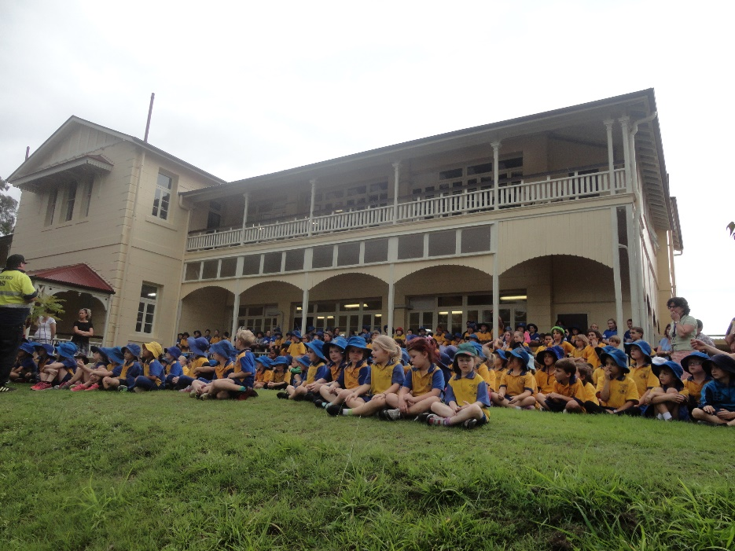**Maryborough Central Student Dress Code**

**Boy’s and Girl’s Uniforms**

* Shirt – Gold polo style shirt with royal blue knitted collar bearing school name, royal blue sleeve trims

with pocket size royal blue school emblem situated on the left hand side.

* Shorts – Royal blue with elastic back and 2 front tucks with pockets (No Denim)
* Socks – plain white or white with blue and gold bands
* Shoes – black leather closed in shoes (flat or low heel) or closed in sports trainers

Additional items

* Skorts – Royal blue
* Skirt – Royal blue skirt with elastic back, 2 inverted pleats front and back with side pocket (No Denim)

**Additional uniform for winter**

* Pullover – plain royal blue or royal blue with large gold school crest
* Windcheater – zip front – royal blue
* Track suit pants – royal blue or royal blue with gold piping along seam (No Denim)

**Hats-** Maryborough Central is a Sun Smart school. The Queensland Cancer Fund recommends brims on hats to be at least 8 cm. Research indicates that a board brimmed hat will reduce the amount of Ultra Violet Radiation reaching the face by 50%. This is equivalent to an Ultraviolet Protection Factor of 2. Therefore caps or hats with less than an 8 cm brim do not comply with our policy. Hats that comply include:

* Soft brimmed (surf) royal blue hat with no less than 8 cm brim, with school emblem or
* Legionnaire cap with school emblem
* All students must wear a hat while outside to reduce harmful effects of the sun. The practice of wearing

hats in a child’s formative years will reduce the incidence of skin cancer later in life. All students must

wear a sun smart hat:

* + before school and at first and second play breaks when outside
  + during Health and Physical Education Lessons
  + during other outdoor lessons and activities

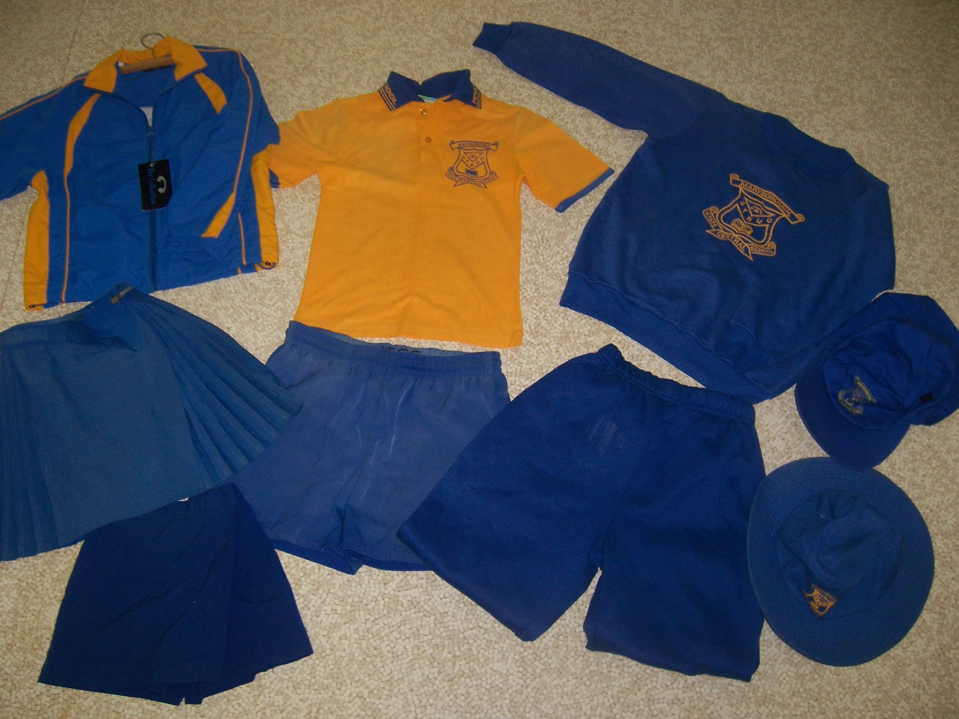

*Uniform items are in gold or royal blue only. Items that include the school crest are preferred but not essential – these may be purchased from Sauers Clothing Supplies, Workers’ Wardrobe and B&H Designs.*

*Non-crest items may be purchased from local department stores providing they are gold or royal blue as pictured above. Acceptable uniform must not include brand names/logos, stripes, patterns or pictures (school crest only – see above).*

**Boy’s and Girl’s Prep Uniform**- For safety reasons Prep polo style shirts are distinctly different to the shirts in Years 1-6. Other items of uniform are the same as listed for boys and girls (above).

* Shirts for both boys and girls are polo shirts with a royal blue back

**Year 6 shirts-** students in Year 6are permitted to wear a Year 6 Senior shirt. This shirt varies from year to year.

**Zone Athletic Shirts and Hats**- students who have purchased Zone shirts and Sun Smart Zone hats forZone athleticsare allowed to wear their Zone shirt and hat to school.

**Swim Shirts**

Improvements to Education Queensland’s Sun Safety Strategy since 2008 make it compulsory for primary school children in state schools to wear sunshirts or T-shirts during school water-based activities. Maryborough Central State School plans to fully comply with this directive. Students without an appropriate sunshirt will not be permitted to participate in water-based activities – no shirt, no swim.

**Band / String Ensemble Uniform**

All students who are members of the school band or strings ensemble are required to wear this uniform for performances in the community and other special performances: blue socks, black shoes, band shirt and long black trousers. The P & C may operate a hire system for the trousers and shirts.

**Bike helmets**

Bike helmets are compulsory for students riding bikes to and from school.

**Sunglasses**

Students are able to wear approved sunglasses at school for outdoor activities. These must bear the student’s name for identification purposes.

**Jewellery**

In the interests of safety, the wearing of jewellery at school is discouraged given that students play during breaks and take part in active class activities and lessons including Health and Physical Education. The wearing of jewellery increases the risk of harm to students.

Students may wear a safe item of jewellery for medical or religious purposes only. This may include:

* one neck chain to be worn inside the shirt - one that does not detract from the school uniform and does not have sharp edges / features
* one flat wrist medical bracelet without sharp edges / features detailing medical emergency needs (medi-alert)

Students may wear one set of small studs / sleepers or one small individual ear stud / sleeper in pierced ears - no dangling earrings are permitted and only one earring per ear is permitted

Students may not wear:

* studs / rings in body parts other than ears
* necklaces that are not for medical or religious purposes
* bracelets that are not for medical purposes
* anklets

**Hair Styles**

Neat practical hairstyles are expected. Both boys and girls are expected to secure long hair to protect against head lice and to avoid interference with desk work and practical activities. Hair colour is strongly discouraged. Students are expected/permitted to wear:

* long hair tied back (for reasons stated above)
* one thin hair band that is preferably the school colours (no bandannas)

**Make-up and Nail Polish**

Students must not wear make-up or nail polish to school.

Applications for students to be exempt from any aspects of the Student Dress Code must be made in writing to the Principal for consideration.

**Appendix 3** **MARYBOROUGH CENTRAL**



**STATE SCHOOL**

**HOMEWORK POLICY**

Homework provides students with opportunities to consolidate their classroom learning, patterns behaviour for lifelong learning beyond the classroom and involve family members in their learning. The setting of homework takes into account the need for students to have a balanced lifestyle. This includes sufficient time for family, recreation and cultural pursuits where appropriate.

Homework can engage students in independent learning to complement work undertaken in class through:

* Revision and critical reflection to consolidate learning (practising for mastery eg reading), camera words and number facts.

**Teacher Responsibilities**

Teachers can help students to establish a routine of regular, independent study by:

* Ensuring the school’s homework policy is implemented
* Setting homework on a regular basis
* Clearly communicating the purpose, benefits and expectations of all homework
* Checking homework regularly and providing timely and useful feedback
* Discussing any homework concerns with parents / carers, and developing and suggesting strategies to assist with homework
* Monitor homework completion. Teachers may implement positive systems that recognise students who consistently complete homework and encourage other students to complete homework. Teachers may apply short-term logical consequences for students who frequently fail to meet homework expectations. These consequences may include –

1. Informal note or phone call to parents
2. Creating opportunities for homework to be completed in school time (class or play)

**Student Responsibilities**

Students can take responsibility for their own learning by:

* Accepting responsibility for the completion of homework tasks within set time frames
* Seeking assistance when difficulties arise
* Organising their time to manage home obligations, participation in other activities etc
* Organising themselves so that homework tasks and materials are taken to and from home
* Seeking assistance from teachers and / or parents when experiencing difficulty

**Parent / Carer Role with Homework**

* Monitor student’s homework
* Set an agreed time for homework to take place
* Provide an appropriate location for the student to complete homework
* Provide support and encouragement as required
* Contact the teacher if the student is experiencing difficulty with homework or if it becomes a source of conflict within the family
* Sign the work and direct the child to stop if he / she has demonstrated a focused effort for the time allocated and the homework is not complete.
* Read to the student, talk with him / her and involve the student in tasks at home including shopping, playing games and physical activity

**Appendix 4**

**MCSS Policy**

**Appropriate Student Use of Mobile Phones and Other Similar Electronic Devices**

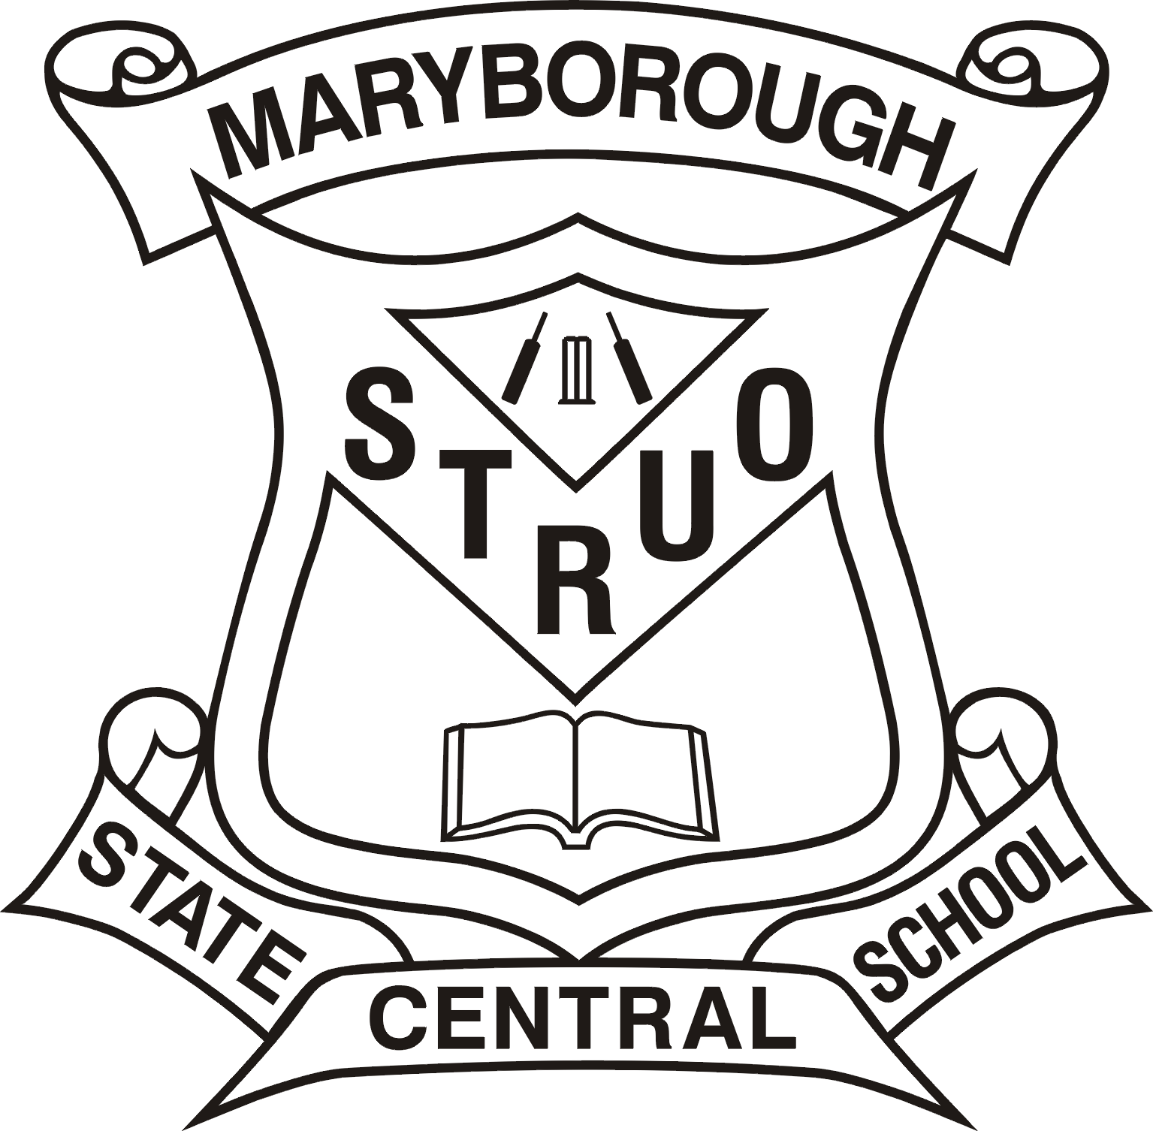

Education Queensland:

“Schools and colleges can make reasonable rules about what students can and cannot bring to school. They can ban anything that is illegal, dangerous or is likely to cause disruption or harm to the smooth running of the school and the education of students.

The use of mobile phones, pagers, portable CD and MP3 players, personal digital assistants and similar electronic devices in class is disruptive to the learning environment of all students and should be discouraged. Students wishing to use these devices in special circumstances should negotiate arrangements with relevant school/college staff.”

**EQ Ref:** 04/19208

The following guidelines relate specifically to the appropriate student use of mobile telephones and similar electronic devices at Maryborough Central State School:

1. Devices must be stored and used in the **school office only**.
2. Devices may not be brought to school unless they are accompanied by an **explanatory note** from the student’s parent / carer.
3. Devices will **not be allowed on excursions or camps** under any circumstances. Parents wishing to contact their children should contact the school - the school will then contact a supervising teacher. For events that occur out of school hours, parents can be provided with the number of a school mobile phone carried by school staff.
4. Devices will be **confiscated** under the following circumstances-
   * They are discovered in a student’s possession without appropriate permission or being used outside of the school office.
   * They are found in school grounds.

Confiscated items will be available for **collection by the student’s parent / carer** at the school office.

1. Devices are stored and used at the owner’s risk. No liability will be accepted by the school in the event of the loss, theft or damage of any device unless it can be established that the loss, theft or damage resulted from the department’s negligence.

j0290185