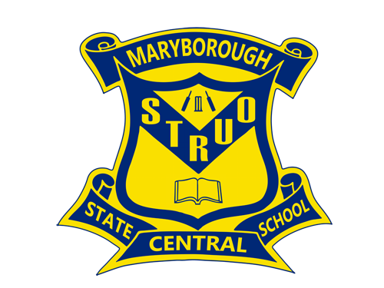
Maryborough Central State School

2025

Student
Code of Conduct

Equity and Excellence: realising the potential of every student
Equity and Excellence outlines the government's vision for a progressive, high-performing education system. Equity and Excellence provides clarity for schools about priorities and expectations, with differentiated support targeted to each school's context and needs.
Queensland Department of Education

Purpose
The Department of Education is committed to provisions that ensures all young Queenslanders have a right to and receive a quality education.
At Maryborough Central State School, we are committed to providing a safe, respectful and disciplined learning environment for all students, staff, parents and visitors.
This plan outlines the responsibilities and processes we use in our school to promote a productive, effective whole school approach to discipline.
Its purpose is to facilitate high standards of behaviour from all in the school community, ensuring learning and teaching in our school is prioritised, where all students are able to experience success and staff enjoy a safe workplace.

Contact Information

Postal address: | 471 Kent St Maryborough 4650
Phone: | 07 41218777
Email: | admin@maryboroughcentralss.eq.edu.au
School website address: | https://maryboroughcentralss.eq.edu.au/
Contact Person: | Mrs. Rebecca Dickens

Endorsement

Principal Name: | Mrs Rebecca Dickens
Principal Signature:
Date: | 23/01/2025
P/C President Name: | Mel Nunan
P/C President Signature:
Date:

Contents

 | Page
Purpose | 2
Contact Information | 2
Endorsement | 2
Consultation | 4
Learning and Behaviour Statement | 5&6
Student Wellbeing and Support Network | 6
Whole School Approach to Discipline | 7&8
MCSS Infractions Chart | 9-10
Whole School Approach to Learning | 11
Consideration of Individual Circumstances | 12
Disciplinary Consequences | 12&13
MCSS Behaviour Flow Chart | 14
MCSS Whole School Positives | 15
School Disciplinary Absences | 16-20
School Policies | 21-31
Temporary removal of student property | 21-25
Use of mobile phones and other devices by students | 25-26
Preventing and responding to bullying | 26-28
Appropriate use of social media | 29-31
Restrictive Practices | 32
Critical Incidents | 33-36
Appendix- School created documents | 37
Learning Reward Menu | 37-38
Smartie Bean tracking ladder and Smartie Bean Certificate | 39
MCSS School Rewards Attendance Criteria | 40
Classroom BUDDY Class Reflection form | 41-43
MCSS Student Dress Code | 44-47
Essential Skills for Classroom Management | 48
MCSS Restorative Practices Prompts | 49
MCSS Expectations Matrix | 50
Conclusion | 51-52

Consultation

Maryborough Central State School developed this plan in collaboration with our school community – parents, staff and students. Consultation was undertaken through discussions held throughout the latter part of 2024. A review of school data sets from 2023 and 2024, relating to attendance, school disciplinary absences and behaviour (both positive and incident records) also informed the development process.

A team of staff and parents leads the development of the Positive Behaviour for Learning (PBL) approach in the school. This lead group meet monthly and consult with staff and community. Their collective work drives the review of the school plan and the key strategies that arise from it.

Parents receive communication discussing concerns about their child’s behaviour when necessary and phone calls and face-to-face meetings also provide opportunities for discussions about data relating to individual students. Parents are welcome to make appointments with the Leadership Team to come in and ask about the behaviour of their children.

This Plan has been endorsed by the Principal and the School Supervisor, in anticipation of consultation with parents in 2025; and will be reviewed as required, and in 2025 as required by legislation.

Learning and Behaviour Statement

At Maryborough Central, our vision is for Equity and Excellence in everything that we do to ensure the potential of every student is recognised, resourced, and responded to.

Values:
- Student Centred Approach –. Engagement and Attendance
- Professional Practices – empowering educators and leaders to build professional expertise ensuring transparency and accountability
- Culture & Inclusion – building a school culture that relies on community to support the work and to ensure inclusion for all through striving for continuous improvement
- Collaboration through consultation - valuing the contribution of students, parents, and families in our school’s decision-making processes
- Capable people delivering the vision – maintaining consistency and continuity through developing solid school processes

All areas of Maryborough Central State School are teaching and learning environments. We consider behaviour management to be an opportunity for valuable social learning as well as a means of maximising the success of academic education programs. We are implementing the research validated ‘Positive Behaviour for Learning’ framework to achieve our identified social behaviour and academic outcomes - reflected in the core elements of the school’s learning approach to behaviour:

- Principal leadership of a team approach to behaviour
- Parent and Community engagement
- Data informed decision making
- Clear consistent expectations for behaviour and
- Explicit teaching of appropriate behaviour to all students

Our Student Code of Conduct outlines our systems for facilitating positive behaviours, preventing new cases of problem behaviours and responding to unacceptable behaviours. Through our school plan, shared expectations for student behaviour (our ‘Behaviour Curriculum’ in the form of a matrix) are plain to everyone, assisting Maryborough Central State School to create and maintain a positive and productive learning and teaching environment, where ALL school community members have clear and consistent expectations and understandings of their role in the educational process.

Students, parents and guardians are clearly and regularly advised of the school’s expectations with regard to the rules and consequences which apply during school related activities (including extra-curricular activities) and while students are representing the school (e.g. wearing school uniform to and from school). Students who do not display appropriate positive behaviours, who choose not to follow school rules and do not represent the school in a positive way may not be invited to attend excursions or camps, or represent the school at academic, cultural or sporting events.
Our school community has identified the following four broad school rules / expectations to teach and promote our high standards of responsible behaviour:

- Self-Responsibility
- Safety
- Respect
- Effort

These rules and values have been used in the development of this Student Code of Conduct. This policy provides an overview of the school’s local policies on the use of mobile phones, social media, rewards and consequences and school expectations.
Our school rules have been agreed upon and endorsed by all staff and our school P&C. They are aligned with the values, principles and expected standards outlined in The Department of Education Code of School Behaviour.

Student Wellbeing and Support Network

Students at Maryborough Central State School are supported through positive reinforcement and a system of universal, targeted, and intensive behaviour support by:
- Parents
- Teachers
- Support Staff
- Administration Staff
- Guidance Officer
- Senior Guidance Officer
- School Chaplain

Students are also supported through our Social Emotional Support program- support from several days per week to daily, for identified students based on individual goals, and staffed by teacher aides and the Chaplain.

Student Council fortnightly meetings are conducted to increase student voice, including representatives from each class in years 3-6 plus elected School Leaders.

Non-Government Organisations such as Anglicare, Churches of Christ Care and Centacare offer Wellbeing Programs for identified students each term.
The Deadly Choices program for indigenous students runs annually to support Aboriginal and Torres Strait Islander students. This is held alongside weekly cultural groups lead and implemented by our school CEC.
RDT Angels Fundraising Charity supplies needy students with a range of food items on a weekly basis.
Parents and students are encouraged to speak with their class teacher or make an appointment to meet with the guidance officer if they would like individual advice about accessing particular services.
External support is also available through the following government and community agencies:
- Disability Services Queensland
- Child and Youth Mental Health
- Queensland Health
- Department of Communities (Child Safety Services)
- Police
- Local Council
- Community based support services

Social skilling programs used within the school include elements of:
- REBOOT program
- Peer Support Program
- Calmer Classrooms
- It’s Not Cool in My School (Qld Police Service)
- Stop Think Do: Lindt Petersen, Allyson Adderley
- Take Control Protective Behaviours Anti-Bullying program
- Anti-Bullying Bystander program
- Are you a Cyber-Bully Bystander? program
- Peer Mediation
- Individualised whole class and small group programs structured by class teachers or by behaviour support personnel – REBOOT

Whole School Approach to Discipline
Differentiated, Explicit, Focussed and Intensive teaching and support

Maryborough Central State School offers a multi-tiered system of support for discipline in the school. Maryborough Central takes a whole-school approach, providing support in all classrooms and programs offered through the school, including sporting activities and excursions.
At Maryborough Central State School we believe that student behaviour is a part of the overall teaching and learning approach in our school. Our staff take responsibility for making their expectations clear, for providing supportive instruction about how to meet these expectations and strive to use behavioural incidents as opportunities to re-teach and reflect.
Our approach shapes, supports and recognises appropriate behaviours in all students.
The first step in facilitating standards of positive behaviour is communicating those standards to all students. At Maryborough Central State School, we emphasise the importance of directly teaching students the behaviours we want them to demonstrate at school. Communicating expectations is a form of universal behaviour support – a strategy directed towards all students designed to prevent problem behaviour and providing a framework for responding to unacceptable behaviour.
Our approach is based on a number of guiding principles:
- clear expectations for student behaviour;
- clear and consistent strategies for teaching appropriate behaviour;
- clear and consistent strategies to encourage appropriate behaviour;
- clear and consistent consequences that discourage inappropriate behaviour

Doing everything we can do to set students up for success is a shared goal of every parent and school staff member. Any students or parents who have questions or would like to discuss the Student Code of Conduct are encouraged to speak with the class teacher or make an appointment to meet with the principal.

The PBL framework uses a three-tiered continuum of evidenced based supports - Tier 1 ‘Universal’; Tier 2 ‘Targeted’; and Tier 3 ‘Intensive’ levels of support services, to facilitate standards of positive behaviour and to respond to unacceptable behaviour. This whole school approach shapes, supports and recognises appropriate behaviour in all students.

School staff utilise strategies for redirecting student behaviour in order from least to most intrusive. Training and refresher sessions in these corrective skills make up some of the professional development sessions that staff engage in throughout the year.

Using a three-tiered approach to facilitating standards of positive behaviour and responding to unacceptable behaviour, it is possible to outline whole school provision of universal, targeted and intensive supports.
- Universal (GREEN ZONE)
In a supportive and well-disciplined school approximately 80% to 90% of students require little, if any, additional support to follow the school rules and demonstrate appropriate social behaviours. Universal levels of support are provided to all students.
- Targeted (YELLOW ZONE)
In a supportive and well-disciplined school approximately 10 to 15% of students may occasionally need additional targeted support, specific adjustments or program intervention. Targeted support is typically delivered in small groups to the identified population.
- Intensive (RED ZONE)
In a supportive and well-disciplined school approximately 2 to 5% of students may need more intensive support and/or flexible learning options to assist them to continue their learning. These are typically individualised interventions for students with highly complex and challenging behaviours.

Universal
80-90%

Targeted
10-15%

Intensive
2-5%

Universal Behaviour Support

A student reward system is an intrinsic part of any behaviour management system and must endeavour to meet both the needs of students and teachers.
Class teachers implement their own classroom rewards program where class behaviour is monitored and rewarded. Teachers use sticker charts, prize draws or other age appropriate options.
Positive Behaviours and award recipients are recorded on OneSchool.
Intervention processes are developed, monitored and evaluated via a School Case Management ( through the Student Support and Wellbeing Committee) process, whereby the school case manager, generally the Principal or HOD Student Services, will communicate with stakeholders and organise case conferences from which intervention plans in the form of Individual Behaviour Management Plans.

Expectations
A matrix of behavioural expectations in specific settings has been attached to each of our four school rules. This matrix outlines our Behaviour Curriculum – our ‘agreed to’ expectations and positive behaviour definitions of appropriate behaviours in all school settings. The following table also outlines examples of minor and major problem behaviours. When identifying minor and major behaviours it is important to consider the intent, frequency, development and age of the student

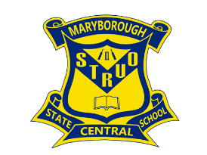
MARYBOROUGH CENTRAL STATE SCHOOL- Student Code of Conduct Infractions Matrix

NB: Repeated behaviours of the following infractions should lead to a higher level being recorded.

Infraction (Listed on ONe SChool) | Definition | Examples – Low Level Behaviours | Examples – Minor Behaviours | Examples – Major Behaviours
Abusive Language | Student delivers verbal messages that include swearing or use of words in an inappropriate way | - Swearing as a reaction  - Inappropriate language or gestures used within conversations  - Conversation that may include swearing | - Swearing at another student (anger based) | - Swearing at adult/student (anger based)  - Racist comments  - Sexual comments  - Name calling student/staff
Disrespect  (Disrespectful language/actions directed at students/staff) | Student intentionally delivers socially rude or dismissive messages to adults or students. | - Calling out in class  - Talking at inappropriate times  - Lying – does not involve others  - Uniform infringements that violate school dress code e.g. no hat, singlet top, visible undergarments, make-up | - Back chatting staff member  - Walking off when being spoken to by an adult  - Clothing or items that do not maintain and foster mutual respect (e.g. printed materials with offensive language or extremist propaganda). | - Persistently yelling at an adult  - Starting false rumours/spreading gossip/lying involving others (yarn carting)  - Constant disrespectful language targeted at a student/staff member
Harassment | Students engages in the repeated delivery of harmful messages in any format related to gender identity; ethnicity; sex; race; religion; disability; physical features or other identity characteristics. | - N.B if a single incidents staff MUST address issue and put under disrespect. If repeated, becomes a major incident in harassment. |  | - Repeated teasing towards another student  - Repeated harmful verbal, physical or social behaviours directed at an individual
Defiance  (refusal to follow teacher directions/complete work) | Students refuse to follow directions given by school staff. Low level will become minor/major if student refuses to stop behaviour after staff member has directed | - Student verbally refusing directions  - Failure to complete work  - Not lining up as directed  - Getting off seat during eating time  - Sporting equipment brought to school  - Not staying with teacher/teacher aide during transitions  - Running on hard surface | - Jumping on seats  - Continued refusal to follow teacher instructions  - Student does not respond to behaviour strategies (ESCMs)  - Getting a drink without permission  - Saying ‘no’ and refusing to follow instructions  - Not following class procedures/routines  - Continual work refusal | - Not going to buddy classroom when directed
Disruption | Students engage in behaviours causing an interruption in a class or school activity or event. Disruption includes sustained loud talk, yelling, or screaming; noise with materials; and/or sustained out-of-seat behaviour. If behaviour is repeated it should be moved to a minor/major depending on severity | - Walking/ running around in the classroom  - Loud noises  - Making noise with materials (tapping, banging)  - Yelling out the answers  - Minor class disruption- Not sitting/displaying whole body listening | - Disruptive behaviour during transitions between learning areas (line up area)  - Persistent calling out  - Sustained loud talking  - Constant wandering in the classroom  - Deliberately distracting others, interrupting their learning | - Disrupting other classes  - Extreme continual class disruption  - Turning over furniture (without intent to harm)
Bullying | Student engages in repeated and deliberate verbal, physical and/or social behaviour intended to cause ongoing physical, social and/or psychological harm. Bullying can occur in person or online (cyberbullying). Bullying may be obvious or hidden. Bullying behaviour is repeated or has the potential to be repeated overtime. | - N.B Single incidents and conflict or arguments between equals, whether in person or online, are not defined as bullying. |  | - Threatening – verbal or physical  - Exclusion  - Constant derogatory comments about another person  - Multiple incidents of similar behaviour  - Ganging-up  - Inappropriate touching of others  - Sexual comments/pictures which are used to intimidate  - Racist comments
Truancy (out of class) | Student is present at school, but is absent from one or more scheduled classes without permission or appropriate reason (i.e. an unauthorised absence) | - Late to class without reason less than 10 minutes (in school grounds, toilet etc)  - Attending non-timetabled class without permission | - Being more than 10 mins late for class without a note from admin  - Leaving classroom without permission  - Handing around outside classrooms/on veranda after being directed by staff to move into classroom  - Being outside of classroom during class time (walking around school grounds, climbing trees, buildings, stairs with limited safety risk)  - Repeatedly being less then 10 mins late to class multiple times in 1 week | - Repeatedly more than 10 mins late for class without a note from admin (in toilet ect. Multiple times in 1 week)  - Student out of classroom, requiring assistance from admin  - Climbing on trees/buildings/outside stairs with major safety risk
Truancy (out of school) | Student is absent from school (morning, afternoon or entire school day) without permission or appropriate reason (i.e. an unauthorised absence) | - Less than 10 mins late to class after being downtown | - More than 10 mins late to class after being downtown | - Leaving school grounds without signed permission or privilege (truanting)  - Repeatedly arriving more than 10 mins late from down town (multiple times in 1 week)  - Absence from school without parent knowledge  - Leaving school environment where it requires Admin to follow up  - Not coming back to school after lunch
Fighting | Student is involved in mutual participation in an incident involving physical violence. | - Gammon fighting that does not escalate | - Gammon fighting requiring intervention  - Repeated gammon fighting | Major- mutual engagement in fighting or instigating a fight (more than 1 person)  - Harming/assaulting another person  - Hitting  - Punching  - Using objects to hurt others  - Slapping  - Biting  - Kicking  - Hair pulling  - Scratching  - Instigating /antagonising fights
Physical Aggression | Student intentionally engages in actions involving physical contact with others where injury may occur (eg. hitting, slapping, punching, hitting with an object, kicking, hair pulling, scratching etc.). This includes premeditated acts or incitement of others to undertake aggression. Physical aggression may be directed towards peers, adults, visitors or animals; or flora or fauna. | - Not keeping hands and feet to self (if repeated becomes a minor) | - Hitting/kicking other students with hands/feet or objects  - Threatening to harm others (physical, verbal, emotional) | Major- singular involvement in physical aggression aimed at others (student or staff)  - Harming/assaulting another person with intent (spitting, kicking, punching, hair pulling, biting)  - Promiscuous/sexualised behaviours including dacking, sac wacking, nipple cripple, touching private areas  - Gesturing inappropriate/sexualised behaviours to staff members/students with intent  - Using objects to hurt others  - Using gestures to threaten  - Intent to injure/intimidate including throwing objects and furniture without causing physical harm.  - Using weapons or threatening with items that may be used as weapons  - Putting hands or arms around neck  Stabbing with sharp objects eg. pencil, compass, scissors
Property Damage | Student participates in an activity that results in destruction, damage or disfigurement of property |  | - Damaging own property  - Graffiti – not difficult to remove | - Punching holes in walls,  - Graffiti – difficult to remove  - Ripping & writing in library books  - Defacing property  - Vandalism  Deliberately breaking school equipment
Theft | Student is involved by being in possession of, having passed on, or being responsible for removing school or someone else’s property. |  | - Using another student’s login details without permission | - Taking someone else’s property e.g. wallet, money  Removing property from another’s bag or desk
Technology Violation | Student engages in inappropriate (as defined by the school) use of mobile phone, drone, smartwatch, camera, computer or other communication device (unless preapproved) . This includes fraudulent or illegal activity such as attempting to hack, implementing DoS attacks, use of key loggers, impersonating staff or other students. | - Disruption caused by technology notifications (smart watches, phones, computers, ipads) must have notifications turned off  - Using mobile phone at school or in class for personal use (including listening to music, playing games)  - Disruption with electronic devices  - Deliberately wasting printing and internet resources | - Use of obscene, inflammatory, racist, discriminatory or derogatory language online using school equipment  - Invading someone’s privacy by recording personal conversations or daily activities and/or the further distribution of such material  - Misuse of digital device, cameras or online platforms  - Using mobile phone, after staff has directed for phone/device to be put away | - Refusal to comply with mobile phone policy (if teacher has directed student to put phone away and/or hand into office) after multiple teacher instruction  - Illegal activity on technology or electronic devices  - Attempted hacking  - Implementing DoS attacks  - Use of key logger software  - Impersonating staff or other students  - Using a mobile phone or other devices in an unlawful manner  - Downloading, distributing or publishing offensive messages or pictures  - Use of language and /or threats of violence that may amount to bullying and/or harassment (online), or even stalking  - Insulting, harassing or attacking others or use obscene or abusive language  - Damage computers, devices or network equipment  - Knowingly downloading viruses or any other programs capable of breaching the department’s network security  - Using in-phone cameras anywhere a normal camera would be considered inappropriate, such as change rooms and toilets
Property misuse causing risk to others | Student engages in misuse of property which may cause risk or injury or ill-health to others. Behaviours involving throwing objects or using objects in an unsafe manner causing injury. | - Littering  - Picking up sticks/rocks or any other item that may be used as a missile  - Inappropriate use of equipment – computers, power points, power tools, electronic whiteboards | - Interfering with school bell  - Projectiles, spit balls etc.  - Deliberate unsafe use of equipment | - Bins kicked over  - Desks pushed over  - Throwing objects  - Unauthorised/inappropriate use of school property  - Weapons – knife/ shanghais/replica firearms/handcuffs or other items that could be used as weapons
Substance misconduct involving tobacco and other legal substance | Student is in possession of, has supplied or is using tobacco, alcohol, other prohibited substances or implements |  | - Having prohibited items including Soft Drinks/Energy Drinks (including Red Bull, KoolAid, Kool C, Mother, V)  - Having prohibited items such as lollies/gum/salty plums | - Aerosol cans  - Consuming prohibited items in the school grounds  - Bringing alcohol, illegal drugs and volatile substances into the school grounds (drugs such as cannabis, ecstasy, or amphetamines)  - Smoking, using, selling or supplying illegal drugs and volatile substances e.g. glue, paint, aerosol cans, petrol  - Attending school seemingly under the influence of alcohol or a drug  - Smoking/cigarettes (including cigarette lighters, matches, electronic cigarettes, whether they contain nicotine or not (pod vapes, vape pens, box mods and vaporizers)  - Consuming over the counter and prescription medication (unless office paperwork has been completed)  Sniffing paint/petrol/textas/glue/deodorant

*Parent collaboration
*Partial attendance
*Daily monitoring
*Staff 1 to 1 Support
*Safety Plans, Safety Risk Assessments
*Individual Behaviour Plans
DIPs
* multi-agency collaboration
* functional behaviour assessment
ORGANISATION
CURRICULUM
*PBL
*REBOOT lessons
*Positive Parent contacts
*Positive School Community Relationships
*Recognition of Success (Curriculum/Behaviour)
*Quality Teaching and Learning Practices
* Differentiation strategies
*Age appropriate pedagogies
* High yield teaching strategies
* Student individual goal setting
*Collaborative planning, moderation and feedback
* Balanced, relevant and engaging curriculum
*Essential Skills for Classroom Management
*Positive Behaviour Plans
*Counselling
*Revisit Social Skilling
*Conflict Resolution
*Involve Support Services
*Examine Curriculum/Environment
*ICPs where relevant
*Revise/Review Class Plan/Rules
*Corrective Strategies (verbal/non-verbal)
* Parental contact
POSITIVE/PREVENTATIVE Differentiated and explicit teaching
SUPPORTIVE/PROBLEM-SOLVING (Focused Support)

RESPONSIVERETRIEVAL (Intensive Support)
INTERPERSONAL
RELATIONSHIPS
Maryborough Central State School Whole School Approach to Support Student Learning

Tier 3 (Behaviour Flow Chart)
5% of students

Tier 2 (BFC)
15-20% of students

Tier 1
Universals
(targeted at all
students)

The model depicts, at all levels of behaviour support and intervention, that there is a focus on relevant curriculum, positive interpersonal relationships, effective organisation and teaching and learning practices.
Consideration of Individual Circumstances

Staff at Maryborough Central State School take into account students’ individual circumstances, such as their behaviour, disability, mental health and wellbeing, religious and cultural considerations, home environment and care arrangements when teaching expectations, responding to inappropriate behaviour or applying disciplinary consequences.
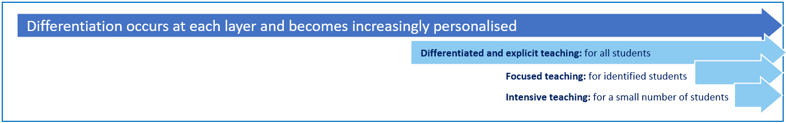
In considering the individual circumstances of each student, we recognise that the way we teach, the support we provide and the way we respond to students will differ. This reflects the principle of equity, where every student is given the support, they need to be successful. This also means that not everyone will be treated the same, because treating everyone the same is not fair. For example, some students need additional support to interpret or understand an expectation. Others may benefit from the opportunity to practise a required skill or behaviour. For a small number of students, the use of certain disciplinary consequences may be considered inappropriate or ineffective due to complex trauma or family circumstances. These are all matters that our teachers and principal consider with each individual student in both the instruction of, and the response to, behaviours.
Our teachers are also obliged by law to respect and protect the privacy of individual students, so while we understand the interest of other students, parents and staff to know what consequence another student might have received, we will not discuss this information with anyone but the student’s family. This applies even if the behaviour incident, such as bullying, involves your child. You can be assured that the school staff take all matters, such as bullying, very seriously and will address them appropriately. We expect that parents and students will respect the privacy of other students and families.
If you have concerns about the behaviour of another student at school, or the way our staff have responded to their behaviour, please make an appointment to speak with the principal to discuss the matter.

Disciplinary Consequences

Maryborough Central State School staff and parents have collaborated to design our system of disciplinary consequences, utlilising data from PBL processes and knowledge of research, and they are in broad agreement with its deployment.

Progression of Consequences
Maryborough Central State School makes systematic efforts to prevent problem student behaviour by teaching and reinforcing expected behaviour on an ongoing basis. When unacceptable behaviour occurs, students experience predictable consequences. Our school seeks to ensure that responses to unacceptable behaviour are consistent and proportionate to the nature of the behaviour. All behaviour incidents (from minor to major) are recorded in OneSchool.
In applying consequences in the classroom setting, the general aim is to minimise disruption to learning and teaching whilst keeping the student within a learning setting and encouraging them to reflect on their behaviour in the interests of developing self-responsibility. For this reason, teachers at

MCSS Behaviour Flow Chart  Student Self-Managed | 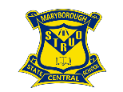
Redirection  (Teacher & Student)  “If you continue to__ then you are choosing to___”  Redirection  (Teacher & Student)  “You have been given opportunities to make better choices and your choice is__”  Teacher/Staff to use logical consequences and REBOOT strategies as options for student to self-regulate their behaviours  Reflection (Playtime)  One School Entry  (Completed by admin)  Parent/Carer Contact  Completed by admin  Learning Environment  Inappropriate Behaviour (Teacher managed using Logical Consequences, Essential Skills for Classroom Management and school wide REBOOT strategies.  Parent/Carer Contact  (By Teacher)  Via phone call or SMS  One School  (By Teacher) Referral to Admin via One School  Form placed in Buddy Class Pigeon Hole  Buddy Class (Learning)  Redirection  (Teacher & Student)  “You need to ___ thanks”  “Thank you for…”  3  2  1  3  2  1  3  1  2 | Return to Positive Behaviours, once consistency of behaviour is being observed – from any Tier.  Time over which these incidents have occurred will be taken into consideration before proceeding to Tier 2.  Teachers may refer to the SSW Committee whenever there is a concern.  4
Parent  Contact  (By Administration)  Behaviour Tracking  Identifying and tracking of behaviour goals– pertinent to individual student needs. Behaviour tracking will be reviewed and will continue until there is evidence of a positive change in behaviour. This process includes the use of student centred negotiated rewards linked to behaviour goals  Reflective Conversation  (Classroom Teacher & Student)  Suspension  (Home/School)  Supervised  Recesses  Individual Support Plan  Behaviour Skilling  1  2  School Social Worker  Referral  SSW Committee  (By Classroom Teacher)  Interview  (Parent/ Teacher/Admin)  Administration  Contact  (By Classroom Teacher) | Major Incident  In the event of a major incident the process would begin at Tier 2.  (Refer to Student Code of Conduct for examples of behaviour)  Parent  Contact  (By Administration)  Once Tier 2 has been reached, the process will begin at Tier 2 if further incidents occur. However, time between incidents and the degree of behaviour would be considered.  3  Mentoring  Behaviour Tracking  Identifying and tracking of “targeted” behaviours” – pertinent to individual student needs.  Behaviour tracking will be reviewed after 2 weeks and will continue until there is evidence of a positive change in behaviour.
School Social Worker
DOCS
FACC
Paediatrician

Psychologist

Suspension
(School/Home)
Complex Behaviours
2 repetitions of Behaviour Tracking
Multi agency collaboration
Partial Attendance
Guidance
Officer
Functional
Analysis

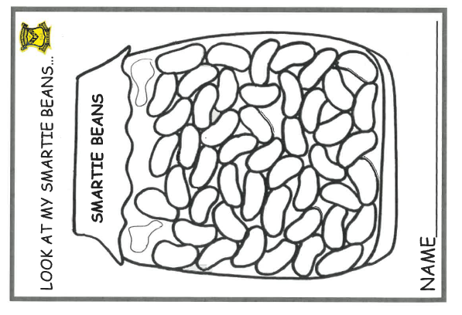MCSS Positives
Whole School Reward System:- “SMARTIE BEANS” (targeted at all students)
Learning |  | Playground “Gotchas”
- “Smartie Beans” are issued by teacher/staff for appropriate behaviour within classroom activities. This is linked to student’s positive choices of school expectations each school day.  - If a student is able to make positive choices of school expectations, they gain their “smartie” for the day. They are unable to access a negative choice based on the school behaviour flow chart.  - Students are able to earn “extra” Smartie Beans randomly for efforts above and beyond expectations  - Students add ‘Smartie Beans’ (bingo marker or coloured dot) to class visual certificate display  - “Double Smartie Bean” days will be announced by admin over the phone system during the term. |  | - Issued by teachers/staff on duty – students take “Gotchas” to classroom  - Classroom Teachers bring their weekly class GOTCHA collection to parade and each class tally contributes to the whole school tally- a moveable tube visual, that when full allows the students to access 20 minutes of extra play  - Four tickets the barrel is drawn out at parade and receive an ice block.  - All “Gotchas” go into an end of Term draw for a prize.  - NB Tickets stored in staff room and each staff member is given a set

Individual
- “Smarties Beans” are stored/displayed as per class organisation.
- When a Target has been reached a certificate is awarded.
- Classroom teachers attach list of students who have attained the next Target to the office before Assembly, so that their names can be placed on the assembly PowerPoint.
- The students are recognized on Assembly and Class Teachers present the certificate during class
- Students can also choose reward from Class Reward Menu each time they receive certificate
- Certificates are stored in the office
- New students are to begin on the level that is averaged across the class- eg if they arrive in Term 2 and most students are on orange, they begin on orange level.

Group
- Class “Smarties” are recorded for school
- Totals announced on parade each week.
- Visual representation of current tally and Target are displayed during Assembly (see below for group targets).- Graph, marbles in bottle, thermometer etc
- Possible Group Rewards –students surveyed for ideas as needed.

Smarties Reward Menu Ideas
When students reach Targets, as well as receiving a recognition on assembly, they will also choose a classroom reward from a menu negotiated by each class and their teacher.
(See the appendix of the Student Code of Conduct for ideas)
Group Targets
Term 1 – 5000
Term 2 – 10 000
Term 3 – 15 000
Term 4 – 20 000
Targets
Orange - 100
Lime - 150
Pink- 200
Yellow- 250
Rainbow- more then 250
School Disciplinary Absences

A School Disciplinary Absence (SDA) is an enforced period of absence from attending a Queensland state school, applied by the Principal as a consequence to address poor student behaviour. There are four types of SDA:
- Short suspension (1 to 10 school days)
- Long suspension (11 to 20 school days)
- Charge-related suspension
- Exclusion (period of not more than one year or permanently).

At Maryborough Central State School, the use of any SDA is considered a very serious decision. It is typically only used by the Principal, or nominated Officer in Charge, when other options have been exhausted or the student’s behaviour is so dangerous that continued attendance at the school is considered a risk to the safety or wellbeing of the school community.

Parents and students may appeal a long suspension, charge-related suspension or exclusion decision. A review will be conducted by the Director-General or their delegate, and a decision made within 40 schools days to confirm, amend/vary or set aside the original SDA decision by the Principal.

The appeal process is a thorough review of all documentation associated with the SDA decision and provides an opportunity for both the school and the family to present their case in the matter. Time is afforded for collection, dissemination and response to the materials by both the school and the family. It is important that the purpose of the appeal is understood so that expectations are clear, and appropriate supports are in place to ensure students can continue to access their education while completing their SDA.

Grounds for suspension
As per the Education (General Provisions) Act 2006, each of the following is a ground for suspension:
- disobedience
- misbehaviour
- conduct that adversely affects, or is likely to adversely affect, other students;
- conduct that adversely affects, or is likely to adversely affect, the good order and management of the school;
- the student’s attendance at the school poses an unacceptable risk to the safety or wellbeing of other students or of staff;
- the student is charged with a serious offence (as defined in the Working with Children (Risk Management and Screening) Act 2000)
- the student is charged with an offence, other than a serious offence, and the principal is reasonably satisfied it would not be in the best interests of other students or staff for the student to attend the school while the charge is pending
Key information:
- Conduct that adversely affects, or is likely to adversely affect, other students, or the good order and management of the school may be a ground/s for suspension even if the conduct does not happen on school premises or during school hours.
Suspensions (1–10 days)
- Principal considers whether the student’s behaviour constitutes grounds for suspension as per section.282 of the Education (General Provisions) Act 2006.
- If the principal decides the behaviour meets one or more of the grounds for suspension under section.282 of the Education (General Provisions) Act 2006, they ensure documentation is completed to explain how they believe the student’s behaviour meets the ground/s (e.g. explain how the behaviour constitutes misbehaviour).
- Principal arranges for the student and parent to have the opportunity to view the relevant evidence under consideration about the behaviour (e.g. reports, statements, other documents, video/audio recordings noting that a copy of the recordings should not be provided to the student or parent but they should be invited to view/hear the recordings at the school or elsewhere before the suspension decision is made).
- Principal ensures the student and the parent are offered the opportunity to discuss the allegations with a school staff member and respond if they choose prior to the principal making a disciplinary decision.
- Principal makes the disciplinary decision to progress or cease the suspension process, including the start and end date of the suspension if relevant.
- Principal or authorised officer tells the student and parent of the decision to suspend, the reasons for the suspension and the date on which it will commence, ensuring the suspension is completed in the current school year and does not extend over the summer holiday period into the new year.
- Principal takes reasonable steps to ensure that parents have made appropriate supervision arrangements prior to the student leaving the school grounds, or alternatively isolate and supervise the student until such arrangements are made.
- Principal ensures a school staff member is appointed as the contact for the student and parent while suspension is in effect and ensures student and parent are advised of the contact information for this person.
- Principal ensures a record for 1–10 day suspension is created and a decision notice is prepared in OneSchool, and gives it to the student parent as soon as practicable.
- Principal ensures signed copies of decision notice (approved forms) and supporting materials relating to the school disciplinary absence decision are uploaded in OneSchool.
- Principal takes reasonable steps to arrange for the student to access an educational program to allow the student to continue with their education during the suspension.

Suspensions (11–20 days)
- Principal considers whether the student’s behaviour constitutes grounds for suspension as per section.282 of the Education (General Provisions) Act 2006.
document
- If the principal decides the behaviour meets one or more of the grounds for suspension under section.282 of the Education (General Provisions) Act 2006, they ensure documentation is completed to explain how they believe the student’s behaviour meets the ground/s (e.g. explain how the behaviour constitutes misbehaviour).
- Principal arranges for the student and parent to have the opportunity to view the relevant evidence under consideration about the behaviour (e.g. reports, statements, other documents, video/audio recordings noting that a copy of the recordings should not be provided to the student or parent but they should be invited to view/hear the recordings at the school or elsewhere before the suspension decision is made).
- Principal ensures the student and the parent are offered the opportunity to discuss the allegations with a school staff member and respond if they choose prior to the principal making a disciplinary decision.
- Principal makes the disciplinary decision to progress or cease the suspension process, including the start and end date of the suspension if relevant.
- Principal or authorised officer tells the student and parent of the decision to suspend, the reasons for the suspension and the date on which it will commence, ensuring the suspension is completed in the current school year and does not extend over the summer holiday period into the new year.
- Principal takes reasonable steps to ensure that parents have made appropriate supervision arrangements prior to the student leaving the school grounds, or alternatively isolate and supervise the student until such arrangements are made.
- Principal ensures a school staff member is appointed as the contact for the student and parent while suspension is in effect and ensures student and parent are advised of the contact information for this person.
- Principal ensures a record for 11–20 day suspension is created and a decision notice is prepared in OneSchool, including details about how to make a submission against the suspension to the Director-General or delegate, and gives it to the student and parent as soon as practicable.
- Principal ensures signed copies of decision notice (approved forms) and supporting materials relating to the school disciplinary absence decision are uploaded in OneSchool.
- Principal takes reasonable steps to arrange for the student to access an educational program to allow the student to continue with their education during the suspension.

Re-entry following suspension
Students who are suspended from Maryborough Central State School are invited to attend a re-entry meeting on the day of their scheduled return to school. The main purpose of this meeting is to welcome the student, with their parent/s, back to the school. It is not a time to review the student’s behaviour or the decision to suspend, the student has already received a consequence through their disciplinary absence from school. The aim of the re-entry meeting is for school staff to set the student up for future success and strengthen home-school communication.

It is not mandatory for the student or their parents to attend a re-entry meeting. It is offered as a support for the student to assist in their successful re-engagement in school following suspension.

Arrangements
The invitation to attend the re-entry meeting will be communicated via telephone and in writing, usually via email. Re-entry meetings are short, taking less than 10 minutes, and kept small with only the Principal or their delegate attending with the student and their parent/s.

A record of the meeting is saved in OneSchool, under the Contact tab, including any notes or discussions occurring during the meeting.

Structure
The structure of the re-entry meeting should follow a structure. If additional items are raised for discussion, a separate arrangement should be made to meet with the parent/s at a later date and time. This meeting should be narrowly focussed on making the student and their family feel welcome back into the school community.

Reasonable adjustments
In planning the re-entry meeting, school staff will consider reasonable adjustments needed to support the attendance and engagement of the student. This includes selecting an appropriate and accessible meeting space, organising translation or interpretation services or supports (e.g. AUSLAN), provision of written and/or pictorial information and other relevant accommodations. The inclusion of support staff, such as guidance officers, School Social Worker or Inclusion teachers, may also offer important advice to ensure a successful outcome to the re-entry meeting.

Exclusion
Principals can make a referral to the Director-General to exclude a student from certain or all Queensland state schools, however the Director-General is the only individual with the authority to exclude students from certain (state schools in a particular area or region) or all state schools in Queensland.

Grounds for exclusion
As per the Education (General Provisions) Act 2006, each of the following is a ground for exclusion:
  - persistent disobedience;
  - misbehaviour;
  - conduct that adversely affects, or is likely to adversely affect,
- other students;
  - conduct that adversely affects, or is likely to adversely affect, the
- good order and management of the school;
  - the student’s attendance at the school poses an unacceptable
- risk to the safety or wellbeing of other students or of staff;
- if suspension of the student is inadequate to deal with the disobedience, misbehaviour, conduct or risk.
It is also ground for exclusion if the student has been convicted of an offence and the principal is reasonably satisfied it would not be in the best interests of other students or of staff for the student to be enrolled at the school.

Process
- Principal considers whether the student’s behaviour constitutes grounds for exclusion as per section.292 of the Education General Provisions) Act 2006.
- Principal considers use of the Behaviour risk assessment tool — safety or wellbeing prior to identifying an appropriate disciplinary response or intervention and retains a copy of the completed risk assessment in OneSchool.
- Principal ensures documentation of how the behaviour meets one or more of the grounds under section.292 of the Education (General Provision) Act 2006 (e.g. explaining how the behaviour adversely affects the good order and management of the school, evidence of conviction of a serious offence.
- Principal arranges for the student and parent to have the opportunity to view the relevant evidence under consideration about the behaviour (e.g. reports, statements, other documents, video/audio recordings noting that a copy of the recordings should not be provided to the student or parent but they should be invited to view/hear the recordings at the school or elsewhere before the proposed exclusion decision is made).
- Principal ensures the student and parent are offered the opportunity to discuss the allegations and respond if they choose prior to the principal making a disciplinary decision.
- Principal makes the disciplinary decision to progress or cease the proposed exclusion process: If not satisfied there is a ground for exclusion, may consider a less serious disciplinary consequence such as suspension or an alternative consequence.
If satisfied there is a ground for exclusion, continues the exclusion process:
- Principal or authorised officer tells the student and parent of the decision to propose exclusion, the reasons for the proposed exclusion, the date on which the suspension will commence and that a final decision about the exclusion will be made within 20 school days.
- Principal takes reasonable steps to ensure that parents have made appropriate supervision arrangements prior to the student leaving the school grounds, or alternatively isolate and supervise the student until such arrangements are made.
- Principal ensures a record for proposed exclusion is created and a decision notice is prepared in OneSchool and ensures it is given to the student and parent as soon as practicable.
- Principal ensures a regional case manager is allocated through OneSchool.
- Principal ensures signed copies of decision notice (approved forms) and supporting materials relating to the school disciplinary absence decision are uploaded in OneSchool.
- Principal takes reasonable steps to arrange for the student to access an educational program to allow the student to continue with their education during the suspension.
- Principal, within 20 school days of notifying the student and parent of the proposed exclusion, and after considering all of the available information, decides whether to exclude or not exclude.
- Principal ensures the exclusion decision is updated in OneSchool and, if the decision is to not exclude, makes arrangements for the return of the student to school and any necessary support provisions. If the decision is to exclude, determines whether to exclude for a period of not more than one school year or to exclude permanently.
- Principal or authorised officer tells the student and parent of the exclusion decision, the reasons for the exclusion and if or when the student can reapply to enrol at the school.
- Principal ensures a decision notice is prepared in OneSchool and gives it to the student and parent as soon as practicable. If the decision is to exclude, the notice includes details about how to make a submission to the Director-General or delegate and, for permanent exclusions, a periodic review submission to the Director-General.
- Principal ensures signed copies of decision notice (approved forms) and supporting materials relating to the school disciplinary absence decision are uploaded in OneSchool at the school
- Failure to make the exclusion decision within the legislated 20 school days will result in the final decision being that the student is not excluded and can return to school.

Key Information:
- Teachers are required to keep behaviour records for students who demonstrate ongoing inappropriate behaviour. Teachers should contact parents/carers and arrange interviews at school or home if disruptive/unacceptable class behaviour continues.
- Ongoing misbehaviour in the classroom or playground will require a behaviour incident report from the staff member. Staff must refer to the Infractions/Low/Minor/Major Behaviour Chart to assist with accurate reporting.
- Students need to be informed of the possible consequences for their actions.
- Students involved in an act of violence or swearing directly at a school staff member will be placed on an immediate Administration Referral. A behaviour incident report must be completed as soon as possible.
- Administration will determine the extent of the consequences for student misbehaviour by taking into account any mitigating circumstances, student age, student behaviour record, number/length of previous suspensions etc.
- Information about students will be kept confidential. Names and consequences will not be used when discussing an incident with the parents or family of another student.
School Policies

Maryborough Central State School has tailored school discipline policies designed to ensure students, staff and visitors work cooperatively to create and maintain a supportive and safe learning environment. Please ensure that you familiarise yourself with the responsibilities for students, staff and visitors outlined in the following policies:

- Temporary removal of student property
- Use of mobile phones and other devices by students
- Preventing and responding to bullying
- Appropriate use of social media

Temporary removal of student property
The removal of any property in a student’s possession may be necessary to promote the caring, safe and supportive learning environment of the school, to maintain and foster mutual respect between all school staff, students and visitors.
This procedure is based on the legislative framework outlined in Division 2, Education (General Provisions) Regulation 2017 (Qld).
Responsibilities
Principal:
Ensures school staff are aware of the responsibilities outlined in this procedure that must be followed when temporarily removing student property, including that:
- consent is not required to search school property such as lockers, desks or laptops that are supplied to the student through the school.
- consent is required from the student or parent to open, examine or otherwise deal with the temporarily removed student property. For example, without the consent of the student or parent, principals or state school staff who temporarily remove a mobile phone from a student are not authorised to unlock the phone or to read, copy or delete messages stored on the phone.
- where there is suspicion that the student has a dangerous item (for example, a knife) in their school bag, principals or state school staff should seize the bag immediately and remove from the student’s access prior to seeking search consent or calling the police. Under no circumstances should the student be permitted to go into the bag themselves.
- under normal circumstances, principals and state school staff members are not permitted to search student property (e.g. a student’s school bag) unless they have the consent of the student or their parent.
- under emergency circumstances only, such as a need to access an EpiPen for an anaphylactic emergency, principals or school staff may need to search a student’s property without the student’s consent or the consent of the student’s parents.
- principals or school staff do not have the authority to search the person of a student, if a search is considered necessary the police should be called to make such a determination.
Ensures parents and students are:
- informed of the procedure which enables school staff to temporarily remove student property and the expectations in relation to property students may bring to school
- aware of the right to refuse permission for state school staff to search student property, and that police may be called if consent is not provided
- provided with clear communication to inform what student property can be temporarily removed and the expectations in relation to property students may bring to school.
Ensures information about this procedure is clearly detailed in the Student Code of Conduct, including:
- that school staff may in certain circumstances remove student property without the consent of parents or students
- the limits on school staff accessing information from temporarily removed student property, such as mobile phones
- examples of property that may be temporarily removed, such as bags, mobile phones, jewellery or prohibited items such as knives
- examples of the amount of time certain property may be temporarily removed (e.g. end of day or school week)
- that student property may be seized by the police.

School staff
Follow appropriate processes outlined in the Student Code of Conduct regarding:
- temporary removal of student property
- access to information on temporarily removed student property (e.g. messages or photos on student mobile phone)
- return of temporarily removed student property
- circumstances where temporarily removed student property need not be made available for collection
- deciding a reasonable time to make temporarily removed student property available for collection.
Students
Must not bring property onto school grounds or other settings used by the school (e.g. camp, or sporting venues) that:
- is illegal (e.g. drugs such as cannabis, ecstasy, or amphetamines)
- puts the safety or wellbeing of others at risk (e.g. knife, firearm, shanghai, handcuffs, replica firearms, or other items that could be used as weapons, cigarettes, cigarette lighters, matches, electronic cigarettes, whether they contain nicotine or not (pod vapes, vape pens, box mods and vaporizers), aerosol cans, spray paint, fuel and glue that could be used as a volatile substance)
- does not preserve a caring, safe, supportive or productive learning environment (e.g. water bombs, soft drink, salty plums, chewing gum, lollies and bubble gum)
- does not maintain and foster mutual respect (e.g. printed materials with offensive language or extremist propaganda).
Must collect their property as soon as possible when advised by the principal or state school staff it is available for collection.
Parents
Ensure their children do not bring property onto school grounds or other settings used by the school that:
- is illegal (e.g. drugs such as cannabis, ecstasy, amphetamines)
- puts the safety or wellbeing of others at risk (e.g. knife, firearm, shanghai, handcuffs, replica firearms, or other items that could be used as weapons, cigarettes, cigarette lighters, matches, e-cigarettes, pod vapes, vape pens, box mods and vaporizers, aerosol cans, spray paint, fuel and glue that could be used as a volatile substance)
- does not preserve a caring, safe, supportive or productive learning environment (e.g. water bombs, soft drink, salty plums, chewing gum, lollies and bubble gum)
- does not maintain and foster mutual respect (e.g. printed materials with offensive language).
It is the responsibility of the parents or carers to collect temporarily removed student property as soon as possible after they have been notified by the principal or state school staff that the property is available for collection.
Process
School Staff
Only persons who are authorised under the Education (General Provisions) Regulation 2017 (Qld) to remove from a student at the school any property in the student’s possession if the principal or staff member is satisfied the removal is necessary.
Temporary removal of student property
Property may be temporarily removed from a student if the principal or school staff are reasonably satisfied the removal is necessary to:
- ensure compliance with the Student Code of Conduct
- preserve the caring, safe, supportive and productive learning environment of the school
- maintain and foster mutual respect among staff and students at the school
- encourage all students to take responsibility for their own behaviour and the consequences of their actions
- provide for the effective administration of matters about the students of the school.

Return of temporarily removed student property
Principal or school staff determine when the temporarily removed student property can be returned, unless the property has been handed to the Queensland Police Service.
Ensure temporarily removed student property held by the school is made available for collection by the student or parent within a reasonable time period.
If the student is a child, the principal or staff member may choose to make the temporarily removed property available for collection to the parent only if it is more appropriate to do so, given:
- its condition, nature or value, and/or
- to ensure the safety of students or staff, and/or
- for the good order and management, administration and control of the school.
Where the student is independent or mature age, it may be appropriate to return the temporarily removed property directly to them. Ensure temporarily removed student property made available for collection is in the same condition as when the property was removed.
Retention of temporarily removed student property
Principal and school staff may retain temporarily removed student property if:
- the property is illegal to possess, threatens the safety or wellbeing of students or staff or is reasonably suspected to have been used to commit a crime and state school staff are in the process of notifying police
- police state that they will come to the school to investigate matters relating to the temporarily removed student property, then it is kept until police attend
- if police decide not to seize the property, return the temporarily removed student property to the student or parent as soon as practicable.
- student or parent has not collected the temporarily removed student property despite reasonable efforts (multiple phone calls, emails or meetings) by the principal or state school staff to advise the student or parent it is available for collection
- where staff reasonably suspect that the student is not the lawful owner of the property

Use of mobile phones and other devices by students

Digital literacy refers to the skills needed to live, learn and work in a society where communication and access to information is dominated by digital technologies like mobile phones. However, the benefits brought about through these diverse technologies can be easily overshadowed by deliberate misuse which harms others or disrupts learning.
This policy reflects the importance the school places on students displaying courtesy, consideration and respect for others whenever they are using personal technology devices.
These devices include mobile phones, tablets, laptop computers, as well as wearable technology or sensing devices.
Etiquette
Students are asked not to bring mobile phones, tablets and other devices to school.
If phones or other personal technology devices are brought to school, they must be signed in to the office before the school day commences and will be returned after 3pm.
If students bring devices to school and they are used, cause disruption or result in disruption or illegal activity the device may be removed as per the Temporary Removal of Student Property policy.
It is unacceptable for students at Maryborough Central State School to:
- Use a mobile phone or other devices in an unlawful manner
- Download, distribute or publish offensive messages or pictures
- Use obscene, inflammatory, racist, discriminatory or derogatory language
- Use language and /or threats of violence that may amount to bullying and/or harassment, or even stalking
- Insult, harass or attack others or use obscene or abusive language
- Deliberately waste printing and internet resources
- Damage computers, devices or network equipment
- Commit plagiarism or violate copyright laws
- Ignore teacher directions for the use of social media, online email and internet chat
- Send chain letters or spam email
- Knowingly download viruses or any other programs capable of breaching the department’s network security
- Use in-phone cameras anywhere a normal camera would be considered inappropriate, such as change rooms and toilets
- Invade someone’s privacy by recording personal conversations or daily activities and/or the further distribution of such material
- Use a mobile phone or device to cheat during exams or assessments
Be aware that:
- Schools may remotely access departmentally-owned student computers or mobile devices for management purposes
- Students who use a school’s ICT facilities and devices in a manner that is not appropriate may be subject to disciplinary action by the school, which could include restricting network or device access
- Despite internal departmental controls to manage content on the internet, illegal, dangerous or offensive information may be accessed or accidentally displayed
- Teachers will always exercise their duty of care, but avoiding or reducing access to harmful information also requires responsible use by the student.

Special Circumstances Arrangement
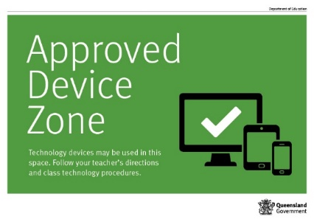
Students who require the use of a personal technology device in circumstances that would contravene this policy (for example to assist with a medical condition or other disability or for a special project) should negotiate a special circumstances arrangement with the Principal.

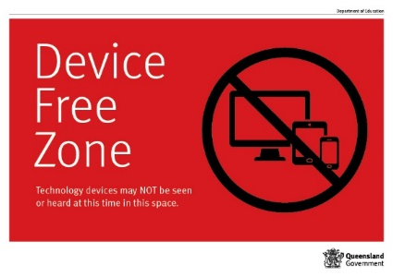

Preventing and responding to bullying
Purpose
Maryborough Central State School strives to create positive, predictable environments for all students at all times of the day. The disciplined and teaching environment that we are creating is essential to:
- achieving overall school improvement, including the effectiveness and efficiency of our student support procedures
- raising achievement and attendance
- promoting equality and diversity and
- ensuring the safety and well-being of all members of the school community.

There is no place for bullying in Maryborough Central State School. Those who are bullied and those who bully are at risk for behavioural, emotional and academic problems. These outcomes are in direct contradiction to our school community’s goals and efforts for supporting all students.
Bullying behaviours that will not be tolerated at Maryborough Central State School include name-calling, taunting, mocking, making offensive comments, kicking, hitting, pushing, taking belongings, inappropriate text messaging, sending offensive or degrading images by phone or internet, producing offensive graffiti, gossiping, excluding people from groups, and spreading hurtful and untruthful rumours.
Bullying may be related to:
- race, religion or culture
- disability
- appearance or health conditions
- sexual orientation
- sexist or sexual language
- children acting as carers
- children in care.

At Maryborough Central State School there is broad agreement among students, staff and parents that bullying is observable and measurable behaviour. When considering whether or not bullying has occurred, we will therefore avoid speculation on the intent of the behaviour, the power of individuals involved, or the frequency of its occurrence. Whether bullying behaviour is observed between students of equal or unequal power, whether it occurs once or several times, and whether or not the persons involved cite intimidation, revenge, or self-defence as a motive, the behaviour will be responded to in similar fashion, that is, as categorically unacceptable in the school community.
Rationale
Many bullying behaviours are peer-maintained through the actions of bystanders. That is, peers react to bullying in ways that may increase the likelihood of it occurring again in the future. Reactions include joining in, laughing, or simply standing and watching, rather than intervening to help the person being bullied. Whilst our school would never encourage students to place themselves at risk, our anti-bullying procedures involve teaching the entire school a set of safe and effective responses to all problem behaviour, including bullying, in such a way that those who bully are not socially reinforced for demonstrating it.
The anti-bullying procedures at Maryborough Central State School are an addition to our Positive Behaviour for Learning processes. This means that all students are being explicitly taught the expected school behaviours and receiving high levels of social acknowledgement for doing so. Adding lessons on bullying and how to prevent and respond to it is a subset of procedures that our students are already accustomed to.
Prevention
Attempting to address specific problem behaviours will not be successful if the general level of disruptive behaviour in all areas of our school is not kept to a low level. Therefore, our schoolwide universal behaviour support practices will be maintained at all times.
This will ensure that:
- Our universal behaviour support processes will always remain the primary strategy for preventing problem behaviour, including preventing the subset of bullying behaviour
- All students know the 4 school rules and have been taught the expected behaviours attached to each rule in all areas of the school
- All students have been or are being taught the specific routines in the non-classroom areas, from exiting the classroom, conducting themselves in accordance with the school expectations in the playground and other areas, to re-entering their classrooms
- All students are receiving high levels of positive reinforcement for demonstrating expected behaviours, including those associated with following our routines, from all staff in the non-classroom areas of the school
- A high level of quality active supervision is a permanent staff routine in the non-classroom areas. This means that duty staff members are easily identifiable and are constantly moving, scanning and positively interacting as they move through the designated supervision sectors of the non-classroom areas.

The student curriculum modules of the anti-bullying process consist of lessons (based on the REBOOT Program) taught by all teachers in all classrooms to a schoolwide schedule of instruction. At all times simultaneous instruction is our goal, in order to maintain consistency of skill acquisition across the school.
An initial introductory lesson is delivered, which teaches the 3-step process to be used by all students when experiencing bullying behaviour either as a person being bullied, the person bullying or bystander.
The introductory lesson is followed by several shorter lessons, each of which focuses on one of the bullying behaviours that the school has identified and defined. These lessons include instruction on how to approach adults and also on what reactions and systemic responses they should expect from adults.
Research indicates that a common outcome of anti-bullying programming is an improvement in understanding of bullying but little change in the frequency or nature of actual bullying behaviour. One of the reasons cited for this outcome is the lack of behavioural rehearsal in the programming. The anti-bullying process at Maryborough Central State School takes care to combine knowledge with practice in a process of active learning, so that students understand by ‘doing’ as much as by ‘knowing’.
Maryborough Central State School records inappropriate behaviour and uses behavioural data for decision-making. This data is entered into our database on a daily basis and can be recalled as summary reports at any time. This facility allows the school to track the effectiveness of its anti-bullying process, to make any necessary adjustments, and to identify specific bullying behaviours that may need to be revisited or revised in the instructional process.

Key contacts for students and parents to report bullying:
Prep to Year 6 –Class teacher, Principal, Head of Student Services, School Social Worker, Guidance Officer

Bullying response flowchart for teachers
- Document the plan of action in One School
- Complete all actions agreed with student and parent within agreed timeframes
- Monitor the student and check in regularly on their wellbeing
- Seek assistance from student support network if needed
Day four
Implement
First hour
Listen
- Provide a safe, quiet space to talk
- Reassure the student that you will listen to them
- Let them share their experience and feelings without interruption
- If you hold immediate concerns for the student's safety, let the student know how you will address these. Immediate in this circumstance is where the staff member believes the student is likely to experience harm (from others or self) within the next 24 hours
- Ask the student for examples they have of the alleged bullying (e.g. hand written notes or screenshots)
- Write a record of your communication with the student
- Check back with the student to ensure you have the facts correct
- Enter the record in One School
- Notify parent/s that the issue of concern is being investigated
Day one
Document
- Gather additional information from other students, staff or family
- Review any previous reports or records for students involved
- Make sure you can answer who, what, where, when and how
- Clarify information with student and check on their wellbeing
Day two
Collect
- Evaluate the information to determine if bullying has occurred or if another disciplinary matter is at issue
- Make a time to meet with the student to discuss next steps
- Ask the student what they believe will help address the situation
- Provide the student and parent with information about student support network
- Agree to a plan of action and timeline for the student, parent and yourself
Day three
Discuss
- Meet with the student to review situation
- Discuss what has changed, improved or worsened
- Explore other options for strengthening student wellbeing or safety
- Report back to parent
- Record outcomes in One School
Day five
Review
- Continue to check in with student on regular basis until concerns have been mitigated
- Record notes of follow-up meetings in One School
- Refer matter to specialist staff within 48 hours if problems escalate
- Look for opportunities to improve school wellbeing for all students
Ongoing
Follow up
Appropriate use of social media

Maryborough Central State School embraces the amazing opportunities that technology and the internet provide to students for learning, being creative and socialising online. Use of online communication and social media sites and applications (apps) can provide positive social development experiences through an opportunity to develop friendships and shape identities.
Maryborough Central State School is committed to promoting the responsible and positive use of social media sites and apps. No student of Maryborough Central State School will face disciplinary action for simply having an account on Facebook or other social media site.
It is unacceptable for students to bully, harass or victimise another person whether within Maryborough Central State School’s grounds or while online. Inappropriate online behaviours can have a negative impact on student learning and the good order and management of Maryborough Central State School, whether those behaviours occur during or outside school hours. This policy reflects the importance of students at Maryborough Central State School engaging in appropriate online behaviour.
Role of social media
The majority of young people use social media sites and apps on a daily basis for school work, entertainment and to keep in contact with friends. Unfortunately, some young people misuse social media technologies and engage in cyberbullying.
Social media by its nature will result in the disclosure and sharing of personal information. By signing up for a social media account, users are providing their personal information.
Students need to remember that the internet is a free space and many social media sites and apps, like Twitter, have limited restrictions placed upon allowable content and regulated procedures for the removal of concerning posts.
Social media sites and apps are designed to share online content widely and rapidly. Once students place information and/or pictures online, they have little to no control over how that content is used.
The internet reaches a global audience. Even if students think that comments or photos have been deleted, there can be archived records of the material that will continue to be searchable into the future.
Inappropriate online behaviour has the potential to embarrass and affect students, others and the school for years to come.
Appropriate use of social media
Students of Maryborough Central State School are expected to engage in the appropriate use of social media. Specific examples of appropriate use of social media sites and apps include:
- Ensuring that personal information, such as full name, address, phone number, school name and location or anyone else’s personal information, is not shared.
- Thinking about what they want to say or post, and how it could be interpreted by others, before putting it online. Remember, once content is posted online you lose control over it. Students should not post content online that they would be uncomfortable saying or showing to their parents’ face or shouting in a crowded room.
- Remembering that it can be difficult to work out whether messages typed on social media sites and apps are meant to be funny or sarcastic. Tone of voice and context is often lost which can lead to unintended consequences. If students think a message may be misinterpreted, they should be cautious and make the decision not to post it.
- Never provoking, or engaging with, another user who is displaying inappropriate or abusive behaviour. There is no need to respond to a cyberbully. Students should report cyberbullying concerns to a teacher and allow the teacher to record and deal with the online concern.
If inappropriate online behaviour impacts on the good order and management of Maryborough Central State School, the school may impose disciplinary consequences for that behaviour regardless of whether the behaviour occurs during or outside of school hours.
Disciplinary consequences could include suspension and/or exclusion. In serious cases of inappropriate online behaviour, the school may also make a report to the police for further investigation.
Maryborough Central State School will not become involved in concerns of cyberbullying or inappropriate online behaviour where the incident in question does not impact upon the good order and management of the school. For example, where cyberbullying occurs between a student of this school and a student of another school outside school hours. Such an incident will be a matter for parents and/or police to resolve.
Laws and consequences of inappropriate online behaviour and cyberbullying
Inappropriate online behaviour may in certain circumstances constitute a criminal offence. Both the Criminal Code Act 1995 (Cth) and the Criminal Code Act 1899 (Qld) contain relevant provisions applicable to cyberbullying.
The Commonwealth Criminal Code outlines a number of criminal offences concerning telecommunications services. The most relevant offence for cyberbullying is “using a carriage service to menace, harass or cause offence to another person”.
The Queensland Criminal Code contains several applicable sections for cyberbullying. Potential relevant criminal offences are:
- Unlawful stalking.
- Computer hacking and misuse.
- Possession of child exploitation material.
- Involving a child in making child exploitation material.
- Making child exploitation material.
- Distribution of child exploitation material.
- Criminal Defamation.
There are significant penalties for these offences.
Maryborough Central State School strives to create positive environments for all students at all times of the day, including while online. To help in achieving this goal, Maryborough Central State School expects its students to engage in positive online behaviours.

Cyberbullying response flowchart for school staff

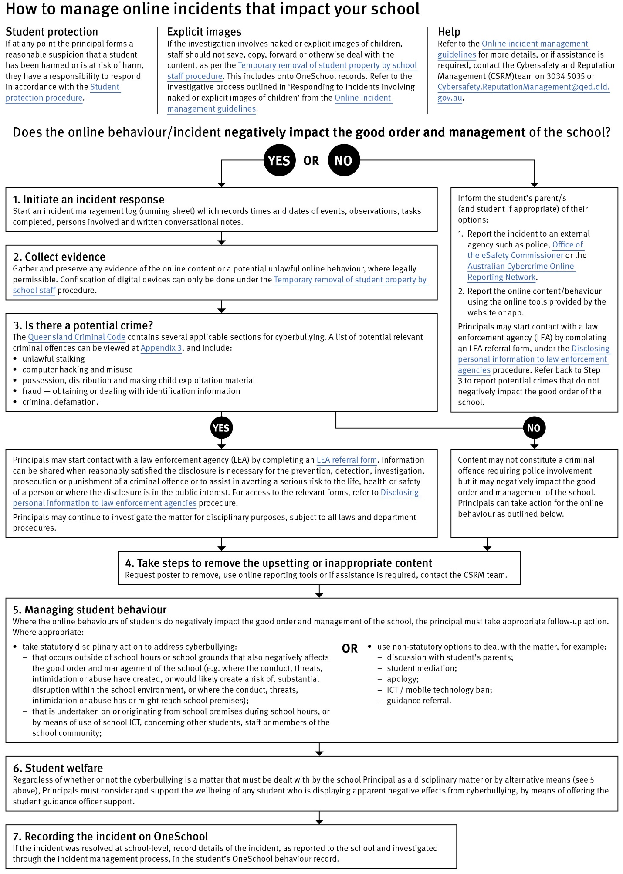

Restrictive Practices

School staff at Maryborough Central State School need to respond to student behaviour that presents a risk of physical harm to the student themselves or to others. It is anticipated that most instances of risky behaviour can be de-escalated and resolved quickly. On some rarer occasions, a student’s behaviour may continue to escalate and staff need to engage immediately with positive and proactive strategies aimed at supporting the student to manage their emotional arousal and behaviour.

In some very rare situations, where there is immediate risk of physical harm to the student or other people, and when all other alternative strategies have failed to reduce the risk, it may be necessary for staff to use restrictive practices.

The use of restrictive practices will always be as a last resort, when there is no other available option for reducing immediate risk to the student, staff or other people. Restrictive practices are not used for punishment or as a disciplinary measure.

The department’s Restrictive practices procedure is written with consideration for the protection of everyone’s human rights, health, safety and welfare. There are six fundamental principles:

- Regard to the human rights of those students
- Safeguards students, staff and others from harm
- Ensures transparency and accountability
- Places importance on communication and consultation with parents and carers
- Maximises the opportunity for positive outcomes, and
- Aims to reduce or eliminate the use of restrictive practices.

Very rarely restrictive practices will be planned and staff will employ, when necessary, pre-arranged strategies and methods (of physical restraint/ mechanical restraint/ clinical holding) which are based upon behaviour risk assessment or clinical health need and are recorded in advance. The use of planned strategies will only be where there is foreseeable immediate risk consistent with the Restrictive practices procedure.

Seclusion will not be used as a planned response and will only be used in serious circumstances for managing an unforeseeable situation in an emergency. It will be used for the shortest time possible and in a safe area that presents no additional foreseeable risk to the student. In such emergencies, a staff member will observe the student at all times and seclusion will cease as soon as possible.

Following the use of any restrictive practice, a focused review will help staff to understand how they responded to the risk in any incident that involved the use of a restrictive practice. Staff will consider whether there are other options for managing a similar situation in the future. This strategy works well for reducing the use of restrictive practices.

All incidents of restrictive practices will be recorded and reported in line with departmental procedures.

Critical Incidents

It is important that all staff have a consistent understanding of how to respond to emergency situations or critical incidents involving severe problem behaviour. This consistency ensures that appropriate actions are taken to ensure that both students and staff are kept safe.
An emergency situation or critical incident is defined as an occurrence that is sudden, urgent, and usually unexpected, or an occasion requiring immediate action.
Severe problem behaviour is defined as behaviour of such intensity, frequency, or duration that the physical safety of the student or others is likely to be placed in serious jeopardy.
Basic defusing strategies
- Avoid escalating the problem behaviour: Avoid shouting, cornering the student, moving into the student’s space, touching or grabbing the student, sudden responses, sarcasm, becoming defensive, communicating anger and frustration through body language.
- Maintain calmness, respect and detachment: Model the behaviour you want students to adopt, stay calm and controlled, use a serious measured tone, choose your language carefully, avoid humiliating the student, be matter of fact and avoid responding emotionally.
- Approach the student in a non-threatening manner: Move slowly and deliberately toward the problem situation, speak privately to the student/s where possible, speak calmly and respectfully, minimise body language, keep a reasonable distance, establish eye level position, be brief, stay with the agenda, acknowledge cooperation, withdraw if the situation escalates.
- Follow through: If the student starts displaying the appropriate behaviour briefly acknowledge their choice and re-direct other students’ attention towards their usual work/activity. If the student continues with the problem behaviour then remind them of the expected school behaviour and identify consequences of continued unacceptable behaviour.
- Debrief: Help the student to identify the sequence of events that led to the unacceptable behaviour, pinpoint decision moments during the sequence of events, evaluate decisions made, and identify acceptable decision options for future situations.

Suicide Intervention Plan

PRIMARY SCHOOL RESPONSE PLAN – MARYBOROUGH CENTRAL STATE SCHOOL
The Response Management Team must meet to discuss the stages below and develop the least intrusive response (Not all actions may be necessary)
Stage 1  Incident Noted | Stage 2  As soon as possible –ensure safety of all | Stage 3  Once safety has been assured | Stage 4  Within 24 hrs | Stage 5  Next Steps
Suicide attempt or death occurs  Disclosure where high risk is identified  (NB. If a significant and serious self-harm incident has occurred, the team may use this plan to support a response). | If necessary -  Call Emergency Services for Fire, Police, Ambulance (000), local numbers (see above)  - Account for everyone  - Ensure the continuing safety of all  - Establish the facts (e.g. Form 1)  - Call Regional Office – Principal Advisor (see contact numbers)  - Convene Response Management Team if not already done  - Activate roles of staff (e.g. Form 2)  Organise communication (e.g. Form 3) | - Confer with family before informing school community if appropriate.  - Arrange to brief staff; Provide staff with developmentally appropriate scripts.  - Determine if students need to be briefed remembering age appropriateness. It may be that you need to brief parents on how to best support their child  - Decide if you need to set up safe/support area (e.g. Form 4)  - Arrange for students to go home – if appropriate.  - Formulate a media and social media response  - Prepare general Parent/Carer information if appropriate (e.g. Form 5 )  Inform P & C President | - Check in with identified people / groups  - Update information  - Share updated information with staff, relatives and students if appropriate  - Plan return to normal procedures  - Prepare formal report  Help-seeking information, external counselling supports, grief and loss information identified and supplied as required | - Continue Support  - Identify those with continuing needs – refer for clinical care support (refer to school specific triangle diagram)  - Involve significant community members where culture is a factor  - Help students with protocols  e.g. funeral arrangements/symbolic events  - Manage any staff absence arrangement  e.g. distress, attending funeral  - Monitor absences  Response Management Team review of incident processes and procedures
EMERGENCY Services
 | Emergency | Local Number
Police | 000 | 4123811
Fire | 000 | 41904846
Ambulance | 000 | 000
SES | 132 500 | 132500
Poison Info Centre | 131 126 | 131126

REGIONAL OFFICE CONTACTS
Role | Name | Phone | Mobile
Regional Director | Lyal Giles
School Supervisor | Leasa Smith
Senior Guidance Officer
Org.
Wellbeing
Employee Assistance

SCHOOL BASED RESPONSE MANAGEMENT TEAM

Role | Name | Phone | Mobile
Principal | Rebecca Dickens | 41218777 | 0488064327
HOD | Leah Ashford | 41218777 | 0419755235
GO | Shane Brogden | 41218777 | 0411257412
School Social Worker | Janine Pohl | 41218777 | 0437413081

Response/Referral Processes

Key Response  Areas | Disclosure *All referrals in the school setting are made to a GO or Principal. | - Keep child safe  - Affirm help-seeking  - Explain limits of confidentiality
Key Response  Areas | Serious and significant self-harm act identified or undertaken. | - Follow school protocols / activate referral pathways  - Engage in response processes as necessary
Key Response  Areas | Devise Risk Management Plan | - Risk management plan for child and parent  - Return to school support / safety plan  - Continue to monitor child  - Ongoing communications and shared management plan with external services
Key Duties and Responsibilities | Guidance Officer | - Reiterate limits of confidentiality  - Advise the Principal of any disclosures and supports  - Gather additional, relevant information  - Provide support in development of risk/safety/support plans  - Consider Student Protection protocols, if necessary –  advise Principal as required
Key Duties and Responsibilities | Principal (or delegate acting on Principal’s request) | - Consider Student Protection protocols, if necessary (use CPG to report)  - Make contact with parents/carers (where safe to do so)  - Arrange formal risk assessment and external referral where necessary  - Provide resources / supports for any plan development
SCHOOL-BASED RESPONSE TEAM: The team should include your school Guidance Officer, other wellbeing staff such as chaplain, the principal or senior staff. The school based team as first line responders should have gatekeeper training. This training provides a broader overview of mental health issues and a general response strategy to work with students (Notice, Inquire, Respond).
Role | Name | Phone | Mobile
Principal
DP
HOC
GO
BSM
Chaplain
Other?
Other?
Other?

The Response Management Team must meet to discuss the stages above and develop the least intrusive response (not all actions may be necessary) Schools may also wish to contact the headspace. School Support Team (hSS). The hSS team is able to work closely with Guidance Officers and schools to enact evidence based and developmentally appropriate suicide postvention. Young children react to and express grief differently from adults. Refer to goodgrief www.goodgrief.org.au for developmentally appropriate information.

Headspace School Support (hSS) Postvention Secondary School support:
Phone: 0455 079 803
https://www.headspace.org.au/schools/

Headspace (hSS) OnePortal School Checklists:
Headspace School Support Procedural Checklist re Suicide

Beyond Blue Suicide Safety Plan for Students
Beyond Blue Safety Plan
More resources from the Suicide postvention for schools at the Headspace website
https://headspace.org.au/schools/
Maryborough Central State School Documents

Learning Reward Menu Ideas 
Academic Activities
- Help the teacher to present a lesson (e.g., by completing sample math problem on blackboard, reading a section of text aloud, assisting cooperative learning groups on an activity)
- Invite an adult "reading buddy" of student's choice to classroom to read with student
- Play academic computer games
- Read a book of his/her choice
- Read a story aloud to younger children
- Read aloud to the class
- Select a class learning activity from a list of choices
- Select a friend as a "study buddy" an in-class work
- Select friends to sit with to complete a cooperative learning activity
- Spend time (with appropriate supervision) on the Internet at academic sites
Helping Roles
- 'Adopt' a younger student and earn (through good behavior) daily visits to check in with that student as an older mentor
- Be appointed timekeeper for an activity: announce a 5-minute warning near end of activity and announce when activity is over
- Be given responsibility for assigning other students in the class to helping roles, chores, or tasks
- Complete chores or helpful activities around the classroom
- Help Mr Andy
- Help in the Library
- Take a note to the main office
Praise/Recognition
- Be awarded a trophy, medal, or prize box pick for good behavior/caring attitude
- Be praised privately by the teacher or other adult
- Design--or post work on--a class or school bulletin board
- Get a silent "thumbs up" or other sign from teacher indicating praise and approval
- Have the teacher call the student's parent/guardian to give positive feedback about the student
- Have the teacher write a positive note to the student's parent/guardian
- Receive a "good job" note from the teacher
Prizes/Privileges/Rewards
- Be allowed to sit, stand, anywhere in the classroom (short of distracting other children) during story time or independent seat work
- Be given a 'raffle ticket' that the student writes name on and throws into a fishbowl for prize drawings
- Draw a prize from the class 'prize box'
- Earn behavior-points or -tokens to be redeemed for prizes or privileges
- Have first choice in selecting work materials (e.g., scissors, crayons, paper) and/or seating assignments
- Have lunch in the classroom with the teacher
- IOU redeemable for credit on one wrong item on a future in-class quiz or homework assignment
- Receive a coupon to be redeemed at a later time for a preferred activity
- Receive a sticker
- Receive pass to "Get out of one homework assignment of your choice"
- Select a class fun activity from a list of choices
- Sit near the teacher
- Take the lead position in line
- Tell a joke or riddle to the class
Recreation
- Be selected by the teacher to accompany another student to a fun activity
- Get time with another class (as a helper)
- Listen to music
- Play a game with a friend
- Play non-academic computer games
- Select fun activity from "Activity Shelf" (stocked with play materials, games)
- Spend time (with appropriate supervision) on the Internet at recreational sites
- Watch part or all of a video (preselected by the teacher and cleared with the student's parent)
- Work on a jigsaw or other puzzle
- Write or draw on blackboard/whiteboard/easel paper

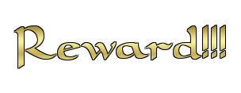

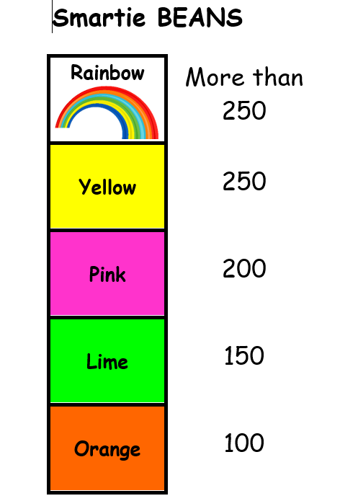

MCSS Rewards Criteria
MCSS Event/Reward Activity | Percentage of Attendance: | Other Criteria- Based on MCSS Student Code of Conduct
School Camps (or any over night trip) | 85% Year to date- up to payment cut off date | 0 Major incidents (including suspension) in the 10 weeks leading to activity  5 or less Minor incidents in the 10 weeks leading to activity  ** For unsuccessful students based on the criteria, a parent must attend and take responsibility for supervising their child at the entire event
Year 6 Graduation | N/A | 0 (Term 4) suspensions
Classroom Rewards (including a day reward excursion) | 85% Year to date- up to payment/or paperwork cut off date | 0 suspensions in the 10 weeks leading up to the activity  2 or less Major incidents in the 10 weeks leading to activity  5 or less Minor incidents in the 10 weeks leading to activity  Participation in the classroom homework program expectations
MCSS Representation at a Maryborough District Level/ Wide Bay Level | 85% - 5 weeks prior to the carnival | 0 suspensions in the term to date  2 or less Major incidents in the term to date  5 or less Minor incidents in the term to date  ** For unsuccessful students based on the criteria, a parent must attend and take responsibility for supervising their child at the entire event
School Curriculum Excursions (linked to a specific learning area) | All students are able to attend- pending other criteria | 0 Major incidents (including suspension) in the 10 weeks leading to activity  5 or less Minor incidents in the 10 weeks leading to activity  ** For unsuccessful students based on the criteria, a parent must attend and take responsibility for supervising their child at the entire event
Whole school extra play- based on term GOTCHA Tally | N/A | If in attendance on the day, whole school participation due to whole school reward targets
Whole school rewards- Based on Smartie Bean whole school challenge | N/A | P-2 and 3-6 teacher and student negotiation of event once target is reached  If in attendance on the day, whole school participation due to whole school reward targets
- NOTES
Monitoring unexplained penalty absences, working towards implementation, communication and education of the MCSS Attendance Strategy in 2026.
- Absences covered (recorded as explained) by a medical certificate or other official documentation maybe taken into consideration when determining the 85% attendance criteria

Classroom BUDDY Class Reflection form
Maryborough Central State School Buddy Class

 | Teacher/student conference – what am I going to see/hear upon return to classroom?
 | Added to One School |  |  |  | 
 | Contacted parent
Name: |  | Class: | Date:
Referring Teacher: |  | Return to class when  form is complete | Return to class when  form and work is complete
Behaviours:
…………………………………………………………………………………………………………………………………………

………………………………………………………………………………………………………………………………………...

What were MY actions that caused the problem?

……………………………………………………………………………………………………………

…………………………………………………………………………………………………………

2
How did I feel when this problem occurred? (circle)


3

When this problem occurred I was in… (circle)

I know this because …………………………………………………………………………….

…………………………………………………………………………………………………………

4
Who did MY actions affect? (name) Another student ……………………………

A teacher …………………………… Other ………………………………………..

5
How did THEY feel when this problem occurred? (circle)

6
How can I fix the problem? (circle or write)

Apologise Follow school rules and routines Keep my hands and feet to myself

Other ……………………………………………………………………………………………………


7
To Reboot Level Up and move back into Smart Brain I can… (circle or write)

Talk to someone Breath Calmly Read or draw

Other ……………………………………………………………………………………………………

8
The reason I made this choice is because… (circle or write)

I wanted attention I wanted revenge I wanted an object

To avoid attention To avoid something Other ……………………………..

9
Which is the main school rule that I need to follow? (circle)

SAFETY EFFORT RESPECT SELF-RESPONSIBILITY

Explain ………………………………………………………………………………………………

…………………………………………………………………………………………………………..

10
What do I need to do next time if I’m feeling the same or a similar situation occurs in the classroom? (circle or write)

Walk away and calm down Ask for help Follow instructions

Other ………………………………………………………………………………………………….

11
I …………………………………… acknowledge that I have made a poor behaviour choice.
I agree that to help me make better choices in the classroom I will: (circle or write)

Use calming strategies Take responsibility for my choices

Ask an adult for help Reflect on my choices and act differently next time

Other …………………………………………………………………………………………………

12
Signed ………………………………. Witnessed by ……………………………………….

Behaviour in buddy class: Good Average Poor

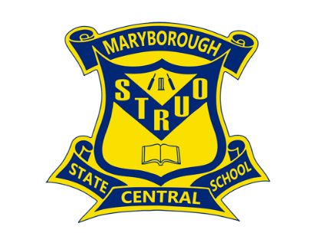

MARYBOROUGH CENTRAL STATE SCHOOL
STUDENT DRESS CODE

This Student Dress Code (SDC) outlines an agreed standard of dress for students at Maryborough Central State School. This SDC has been developed in consultation with parents/carers, staff and students. Central’s SDC reflects school community standards and is consistent with occupational health and safety and anti-discrimination legislation.

Students at Maryborough Central are expected to adhere to the SDC when:
- attending the school
- representing the school
- travelling to and from school
- engaging in school activities out of school hours

Our school SDC provides clothing that aims to contribute to a safe and supportive teaching and learning environment through:
- ready identification of students and non-students at school
- fostering a sense of belonging
- developing mutual respect among students by minimising visible evidence of economic or social differences
- sun safety

Our SDC clearly documents all aspects of the school uniform i.e., reasonable clothing, including headwear and footwear, that students are expected to wear. It also documents acceptable standards in relation to other aspects of personal presentation of students.

Acceptable or reasonable dress refers to clothing or apparel that would be socially acceptable, although it does not conform to Maryborough Central’s SDC. Inappropriate dress refers to clothing or apparel worn by students that is deemed to be:
- Offensive
- Likely to disrupt or negatively influence normal school operations
- Unsafe for student or others
- Likely to result in a risk to health and safety of student or others.

In resolving matters of student dress code Maryborough Central considers:
- Families requiring sufficient time to purchase items of dress
- Economic hardship requiring special arrangements, or extended period of time, to purchase new items of dress
- Students with recognised disabilities requiring greater flexibility in interpretation of dress code
- Conscientious objections, for example objections raised on any reasonable religious grounds.

Maryborough Central does have:
- Alternative arrangements for a set period of time upon receipt of written request from parents/carers or by negotiation with the principal or delegate.
- Opportunities to wear and keep relevant items of dress code from a bank of items held at the school in times of hardship or emergency replacement of items.

In individual cases of conflict with Maryborough Central’s SDC, or persistent failure to uphold the code or a student is inappropriately dressed the school may:
- Offer appropriate item/s from the bank of clothing held at school
- Take action that prevents risk to the student or others, or action that maintains normal school operations
- Inform the student’s parents or carers of incident and discuss further with parents or carers, representatives of school and the student to prevent a recurrence
- Implement a process of conflict resolution or mediation if the student persistently wears inappropriate dress after discussions have been held with parents/carers.

Where a student is reasonably dressed but does not conform to the Student Dress Code the Principal or Principal’s delegate will:
- offer appropriate item/s from the bank of uniform clothing held at school
- inform parents or carers of the incident and, if necessary, discuss further
- use appropriate conflict-resolution or mediation if the student persistently fails to observe the Student Dress Code

In accordance with departmental policy Maryborough Central may impose sanctions on a once only basis per episode of non-compliance. Sanctions are reflective of the severity and recentness of the non-compliance and are limited to one of the following:
- Imposing a loss of play privilege for a student during lunch (parents will be informed before reflection occurs);
- Preventing a student from attending, or participating in, any activity for which the student is representing school; or
- Preventing a student from attending or participating in any school activity that is not an essential school educational program.

Non compliance with the Maryborough Central Student Dress Code will:
- not result in exclusion or suspension or cancellation of enrolment
- not result in sanctions that damage academic prospects
- not result in prevention from continuation in participation in essential curriculum activities except where necessary for reasons of safety (provision of alternative educational activities will be made in this situation)
- not result in disadvantage where required dress code items are not available because of circumstances beyond control
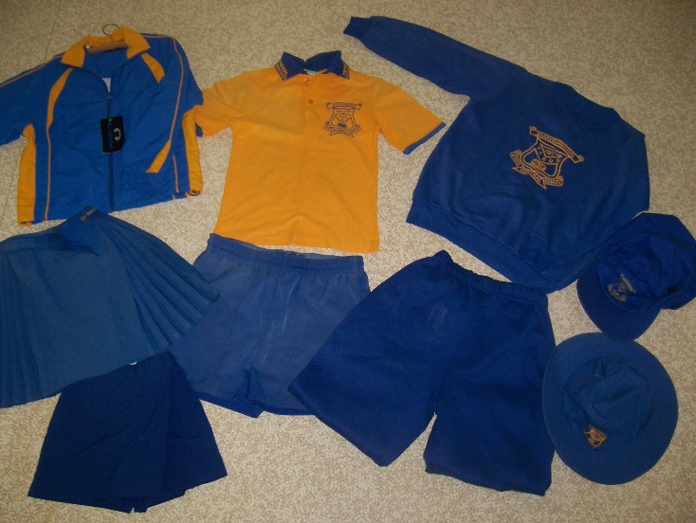

Maryborough Central Student Dress Code
Girl’s Uniform
- Shirt – Gold polo style shirt with royal blue knitted collar bearing school name, royal blue sleeve trims with pocket size royal blue school emblem situated on the left-hand side.
- Skirt – Royal blue skirt with elastic back, (No Denim)
- Shorts – Royal blue with elastic back (No Denim)
- Skorts – Royal blue
- Socks – plain white or black
- Shoes – black leather closed in shoes (flat or low heel) or closed in sports trainers

Boy’s Uniform
- Shirt - Gold polo style shirt with royal blue knitted collar bearing school name, royal blue sleeve trims with pocket size royal blue school emblem situated on the left-hand side.
- Shorts – Royal blue (No Denim)
- Socks – plain white or black
- Shoes – black leather closed in shoes (flat low heel) or closed in sports trainers

Boy’s and Girl’s Prep Uniform- For safety reasons Prep polo style shirts are distinctly different to the shirts in Years 1-6
- Shirts for both boys and girls are polo shirts with a royal blue back
- Other items of uniform are the same as listed for boys and girls (above)

Additional uniform
- Pullover – plain royal blue or royal blue with large gold school crest
- Windcheater – zip front – royal blue
- Track suit pants – royal blue or royal blue (No Denim)
- Senior shirt for Year 6 or graduating class students
- JUMPERS OUTSIDE OF WINTER MONTHS – students will be able to bring a jumper to wear in the classroom whilst the air-conditioning is in use. In the interest of health and safety and hygiene, they will however need to remove them to leave the room to play/eat or participate in any activities

Hats- Maryborough Central is a Sun Smart school. The Queensland Cancer Fund recommends brims on hats to be at least 8 cm. Research indicates that a board brimmed hat will reduce the amount of Ultra Violet Radiation reaching the face by 50%. This is equivalent to an Ultraviolet Protection Factor of 2. Therefore, caps or hats with less than an 8 cm brim do not comply with our policy. Hats that comply include:
- Soft brimmed (surf) royal blue hat with no less than 8 cm brim, with school emblem

All students must wear a hat while outside to reduce harmful effects of the sun. The practice of wearing hats in a child’s formative years will reduce the incidence of skin cancer later in life. All students must wear a sun smart hat:
- before school and at first and second play breaks when outside
- during Health and Physical Education Lessons
- during other outdoor lessons and activities
Maryborough Central does NOT share hats or give students hats unless prearranged with parents due to hardship or emergency, due to headlice control measures.
Uniform items are in gold or royal blue only. Items that include the school crest are preferred but not essential – these may be purchased from Sauers Clothing Supplies, Workers’ Wardrobe and B&H Designs.

Non-crest items may be purchased from local department stores providing they are gold or royal blue as pictured above. Acceptable uniform must not include brand names/logos, stripes, patterns or pictures (school crest only – see above).

Zone Athletic Shirts and Hats- students who have purchased Zone shirts and Sun Smart Zone hats for Zone athletics are allowed to wear their Zone shirt and hat to school.

Deadly Choices Shirts – indigenous student who have participated in deadly choices and received a shirt will be able to wear these shirts during NAIDOC/ Reconciliation weeks and during identified cultural days.

Swim Shirts
Improvements to Education Queensland’s Sun Safety Strategy for 2008 make it compulsory for primary school children in state schools to wear sunshirts or T-shirts during school water-based activities. Maryborough Central State School plans to fully comply with this directive. Students without an appropriate sunshirt will not be permitted to participate in water-based activities – NO SHIRT, NO SWIM.

Band/String Ensemble Uniform
All students who are members of the school band or strings ensemble are required to wear this uniform for performances in the community. Uniforms will be provided by the school P&C to be borrowed at the time of events.

Jewellery
In the interest of safety, the wearing of jewellery at school is discouraged. The wearing of jewellery increases the risk of harm to students and loss of property. Students may wear small studs/sleepers in pierced ears - no dangling earrings are permitted and only one earring per ear is permitted

Students may wear some jewellery for medical or religious purposes only.
This may include:
- one neck chain to be worn inside the shirt - one that does not detract from the school uniform and does not have sharp edges/features
- one flat wrist medical bracelet without sharp edges/features detailing medical emergency needs (medi-alert)

Students may not wear:
- studs/rings in body parts other than ears
- necklaces that are not for medical or religious purposes
- bracelets that are not for medical purposes
- anklets

Hair Styles
Neat practical hairstyles are expected. Both boys and girls are expected to secure long hair (hair past shirt collar length) to protect against head lice and to avoid interference with desk work and practical activities. Natural hair colour is expected, no strong unnatural colours are permitted.
Students should wear hair accessories that are safe and in school colours including scrunchies, bows and head bands
Make-up
Students must not wear make-up to school.

Nail Polish
Students must not wear nail polish to school.

Applications for students to be exempt from any aspects of the Student Dress Code must be made in writing to the principal for consideration.

Essential Skills for Classroom Management (ESCM)

What are the ESCM?
There are 10 ESCM that teachers should use to help in the management of their classrooms. They are a tool to be used to help teachers develop a supportive and positive classroom with minimal interruptions and give them the skills to deal with inappropriate behaviours in the least intrusive ways possible.
The 10 essential skills are:
- Establishing expectations
  - Clearly articulate and demonstrate the boundaries of prosocial behaviour.
- Giving instructions
  - Give a clear direction about what students are to do.
- Waiting and scanning
  - Wait and look at your students for 5-10 seconds after you give an instruction.
- Cueing with parallel acknowledgement
  - Acknowledge students’ on-task behaviour with the intention of encouraging others to copy.
- Body language encouraging
  - Intentionally use your proximity, body gestures and facial expressions to encourage students to remain on-task.
- Descriptive encouraging
  - Encourage students to become more aware of their competence by describing exactly what you see or hear from them that you hope to see more frequently.
- Selective attending
  - Deliberately give minimal attention to safe, off-task or inappropriate behaviour.
- Redirecting to learning (verbal and non-verbal)
  - Respectfully prompt the student who is off-task or disrupting others, initially with a redirection to the learning. This can be verbal or non-verbal.
- Giving a choice
  - Respectfully confront the student who is disrupting others with the available choices and their natural consequences.
- Following through
  - Resolute, planned action in the face of extended off-task behaviour, on on-going disruptive behaviour that is seriously disturbing the learning environment.

Restorative Practices
At Maryborough Central we….
REBOOT LEVEL BACK UP INTO LEARNING
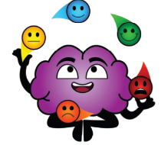   |  | 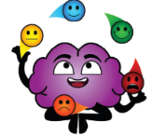
What choices did you make? | Who has been affected? | What do I need to do to REBOOT Level up and fix things? | How can I make a better choice next time?

MARYBOROUGH CENTRAL Behaviour Matrix
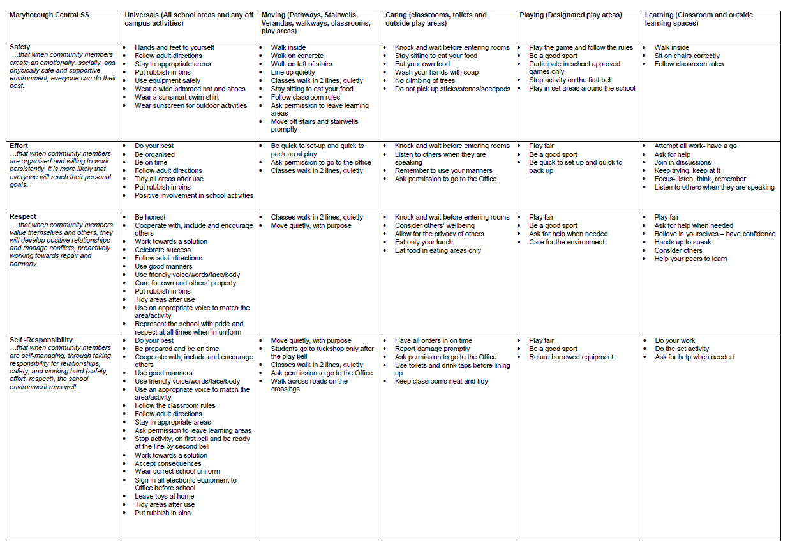
Conclusion

Maryborough Central State School staff are committed to ensuring every student is supported to feel safe, welcome and valued in our school. There may, however, be occasions where parents need to raise a concern or make a complaint about an issue you feel is adversely affecting their child's education.

All Queensland state schools are committed to ensuring that all complaints - whether they relate to a school staff member or a school's operations - are dealt with in a fair and equitable manner. As a parent or carer, you can express dissatisfaction with the service or action of the Department of Education or its staff, including decisions made or actions taken in a school and/or by the local regional office.

As a complainant, it is your responsibility to:
- give us a clear idea of the issue or concern and your desired solution
- provide all the relevant information when making the complaint
- understand that addressing a complaint can take time
- cooperate respectfully and understand that unreasonable, abusive, or disrespectful
conduct will not be tolerated
- let us know if something changes, including if help is no longer needed.

The Department of Education may not proceed with your complaint if your conduct is unreasonable.

In most instances, staff members are told of complaints made about them and offered the right of reply. A complainant also has the right to have a support person throughout the process.

The following three-step approach assists parents and school staff in reaching an outcome that is in the best interests of the student:

- Early resolution: discuss your complaint with the school
The best place to raise any concerns is at the point where the problem or issue arose. You can make an appointment at the school to discuss your complaint with your child’s teacher or the principal. You are also welcome to lodge your complaint in writing or over the phone. You can also make a complaint through QGov.

Complaints may be lodged by telephone, writing or in electronic format. Email addresses can be accessed through the schools directory.

- Internal review: contact the local Regional Office
If, after taking the early resolution step, you are dissatisfied with the outcome of your complaint or how the complaint was handled, you can ask the local regional office to conduct a review. You need to submit a Request for internal review form within 28 days of receiving the complaint outcome.
- External review: contact a review authority
if you are dissatisfied after the internal review, you may wish to contact a review authority, such as the Queensland Ombudsman, and request an independent, external review. More information about external review options is available at www.ombudsman.qld.gov.au.

Some matters need to be handled in a different way to school matters and will be referred to other areas in the department. These include:
- issues about harm, or risk of harm, to a student attending a state school, which must be managed in accordance with the Student protection procedure.
- complaints about corrupt conduct, public interest disclosures; or certain decisions made under legislation, which will be dealt with as outlined in the Excluded complaints factsheet.

